**

MOBILE APPLICATION FOR FOOD RECOMMENDATION BASED ON USER’S MOOD USING AI MODELS

A thesis submitted to the School of Computer Science and Engineering   
in partial fulfilment of the requirement for the degree of   
Bachelor of Information Technology/Computer Science/Computer Engineering.

In specialization

By

Mr: Le Thanh Phuong Nam

ID (HCMIU): ITITWE19025  
Student number (UWE): 23083609

International University - Vietnam National University HCMC   
University of the West of England

May 2025

**MOBILE APPLICATION FOR FOOD RECOMMENDATION   
BASED ON USER’S MOOD USING AI MODELS**

By Le Thanh Phuong Nam

Under the guidance and approval of the committee, and approved by all its members, this thesis has been accepted in partial fulfillment of the requirements for the degree.

APPROVED BY: ________________________________   
*Dr. Vi Chi thanh*

________________________________   
(*Typed Committee name here*)

________________________________   
(*Typed Committee name here*)

________________________________   
(*Typed Committee name here*)

________________________________   
(*Typed Committee name here*)

THESIS COMMITTEE   
(Whichever applies)

# Acknowledgments

I would like to express my deep gratitude and appreciation for all the necessary resources and spiritual backing that enabled me to finish this thesis. First of all, I would like to thank my supervisor, Dr. Vi Chi Thanh, who has supported me a lot throughout the process. From his encouragement to his dream offers, he has motivated me to make every effort to complete my research. In addition, he also supported me in building a planned working mindset right from the very beginning when they were just ideas.

Furthermore, I am also truly grateful to the lecturers and staff of the Faculty of Computer Science and Engineering at International University, Vietnam National University, Ho Chi Minh City, for providing me with a strong enough amount of knowledge and resources to improve my understanding every day to achieve such results, not only in this field but also in many other fields. Subsequently, the vast resources from the E-library of the University of the West of England have provided major support in accessing valuable scientific articles and research that usually require payment if I were not a UWE student.

Finally, I would like to thank my parents, relatives and friends, especially Huynh Ngoc Thuy Vy. These people often do not directly encourage me, but the hidden feelings they have for me come from their trust and concern for my health. That is an invaluable source of motivation to help me pursue my goals in studying and in my future career path.

# Plagiarism Statements

My thesis contains original material using personal language and ideas, together with original materials, unless I mention specific references. I also declare that it has not been presented for evaluation in any other educational or research program. I am aware that any deviation from this statement will automatically disqualify me from graduating from International University - Vietnam National University Ho Chi Minh City and the West of England.

# Copyright Statement

This copy of the thesis has been provided for consultation with the understanding that the author retains full copyright. An author needs to approve the publication of any documentation and information before using it.

© Le Thanh Phuong Nam/ ITITWE19025/ 23083609/ 2019-2025

# Table of Contents

Acknowledgments i

Plagiarism Statements ii

Copyright Statement iii

Table of Contents iv

List of Figures vii

List of Tables ix

List of Appendixes x

Abbreviations xi

Abstract xii

Author Keywords xiii

Chapter One - Introduction 1

1.1. Background 1

1.2. Problem Statement 1

1.3. Scope and Objectives 2

1.4. Assumption and Solution 3

1.5. Structure of thesis 3

Chapter Two – Literature Review 5

2.1. Introduction to Literature Review 5

2.2. Theoretical Background 5

2.2.1. Recommender Systems 5

2.2.2. Nutrients and mood Relationship 6

2.3. Technical Background 10

2.3.1. Content-based Filtering 10

2.3.2. Machine Learning 12

2.3.3. Emotion Recognition Approaches 14

2.4. Related Work 15

Chapter Three – Methodology 16

3.1. Methodology Overview 16

3.2. User requirement 16

3.2.1. Functional Requirements 16

3.2.2. Non-Functional Requirements 17

3.2.3. Stakeholder Identification 17

3.2.4. MoSCoW Prioritization 18

3.2.5. Use Case Diagram 19

3.3. Model Components and Approaches 20

3.3.1. Facial emotion image detection 20

3.3.2. Compatibility score evaluation 21

3.4. Experimental Design & Setup 23

3.4.1. Experiment Objectives and Evaluation Metrics 23

3.4.2. Experiment A: 25

3.4.3. Experiment B: 27

3.5. System Design 32

3.5.1. System Architecture Diagram 32

3.5.2. Relational Database Diagram 32

3.5.3. Class Diagram 33

3.5.4. Sequence Diagram 34

3.5.5. UI/UX Design 35

Chapter Four - Implementation 37

4.1. Implementation Overview 37

4.2. Experiments Implementation 37

4.2.1. Experiment A Implementation 37

4.2.2. Experiment B Implementation 40

4.3. Mobile application implementation 45

4.4. Backend System Implementation 46

Chapter Five – Result and Discussion 49

5.1. Evaluation Overview 49

5.2. Performance Visualization and Interpretation 49

5.3. Performance of Individual Models 51

5.4. Nutrient Correlation with Model Prediction 54

5.5. Comparative Evaluation with Direct Scoring 56

5.6. Comprehensive Evaluation 57

5.7. Personalization Feedback Simulation 58

5.8. Discussion and Implications 58

Chapter Six – Conclusion and Future Work 60

6.1. Conclusion 60

6.2. Future Work 60

APPENDIX 61

REFERENCES 69

# List of Figures

Figure 2.1. Classification of Recommender Systems by Centricity, Dimensions, and Delivery Mode 6

Figure 2.2. Conversion Formula from Caloric Ratio to Milligram Intake 10

Figure 2.3. Content-Based Filtering Process Flow 11

Figure 2.4. General Formula of Cosine Similarity 11

Figure 2.5. Vector-based Cosine Similarity Formula 12

Figure 2.6. Conceptual Hierarchy of Machine Learning, Shallow Learning, and Deep Learning (Janiesch, Zschech and Heinrich, 2021) 12

Figure 2.7. Workflow of Random Forest algorithm using bootstrap sampling and aggregation 13

Figure 3.1. Use Case Diagram 20

Figure 3.2. Facial Emotion Image Model Classification Report 21

Figure 3.3. Facial Emotion Image Model Confusion Matrix 21

Figure 3.4. Priority Weight Normalization Process 22

Figure 3.5. Nutrient Suitability Factor Evaluation 23

Figure 3.6. Total Compatibility Score Computation 23

Figure 3.7. Recommendation Approach Flow 26

Figure 3.8. Inverse Compatibility Score Formula 29

Figure 3.9. Total Score Including User Preference 29

Figure 3.10. Food Recommendation Pipeline 30

Figure 3.11. System Architecture Diagram 32

Figure 3.12. Relational Database Diagram 33

Figure 3.13. Class Diagram 34

Figure 3.14. Sequence Diagram 35

Figure 3.15. UI/UX Design 36

Figure 4.1. Boxplot of nutritional attributes 38

Figure 4.2. Pipeline for Mood-Optimized and Personalized Models 39

Figure 4.3. Meal Type Distribution 41

Figure 4.4. Food Type Distribution 42

Figure 4.5. Meal Distribution by Day of the Week 42

Figure 4.6. Nutrient distribution boxplot 43

Figure 4.7. Three-Model System Integration 44

Figure 5.1. Learning Curves (Binary Classification Model) 49

Figure 5.2. Learning Curves (Compatibility Score Model) 50

Figure 5.3. Learning Curves (Rank Prediction Model) 50

Figure 5.4. Top Features for Compatibility Score Prediction 51

Figure 5.5. SHAP Feature Importance (for regression model) 52

Figure 5.6. Top features for Food Ranking 52

Figure 5.7. SHAP Feature Importance (for binary model) 53

Figure 5.8. Top features for Good/Bad Food Match Classification 53

Figure 5.9. Confusion matrix of Good/Bad Food Match Classification 54

Figure 5.10. Correlation of Key Nutrients with Model Predictions by Emotion 55

Figure 5.11. Average Compatibility of Food Types by Emotion 56

Figure 5.12. Statistical Comparison 56

Figure 5.13. Overall Comprehensive Evaluation Results 57

# List of Tables

Table 3.1. Functional Requirements 16

Table 3.2. Non-Functional Requirements 17

Table 3.3. Stakeholder Identification 17

Table 3.4. MoSCoW Prioritization 18

# List of Appendixes

Appendix A. Monthly Project Timeline 62

Appendix B. Gantt Chart of Project Execution 63

Appendix C. Work Breakdown Structure (WBS) 63

Appendix D. List of priority nutrients in different moods table 66

Appendix E. Recommended Daily Intake For each Nutrient table 68

Appendix F. Github Source Code 68

# Abbreviations

|  |  |
| --- | --- |
| **Abbreviation** | **Definition** |
| AI | Artificial Intelligence |
| ML | Machine Learning |
| MFQ | Mood and Feeling Questionnaire |
| CSV | Comma-Separated Values |
| Flask | Flask Web Framework |
| EFSA | European Food Safety Authority |
| RCTs | Randomized controlled trials |
| HPA | Hypothalamic–Pituitary–Adrenal |
| NMDA | N-Methyl-D-Aspartate |
| VIT | Vision Transformer |
| SVM | Support Vector Machine |
| KNN | K-Nearest Neighbors |
| TPH2 | Tryptophan Hydroxylase 2 |
| GABA | Gamma-Aminobutyric Acid |
| PUFAs | Polyunsaturated Fatty Acids |
| DHA | Docosahexaenoic Acid |
| EPA | Eicosapentaenoic Acid |
| CBF | Content-Based Filtering |
| API | Application Programming Interface |
| JWT | JSON Web Token |
| MVC | Model-View-Controller |
| UI/UX | User Interface / User Experience |
| SHAP | SHapley Additive exPlanations |
| MSE | Mean Squared Error |
| R² | Coefficient of Determination |
| IoT | Internet of Things |

# Abstract

Nowadays, AI is gradually changing the way people access information and make decisions, so the application of AI in personalized nutrition is becoming increasingly necessary. The thesis develops a method that applies AI to generate food recommendations according to user mood expressions. The essential part of the recommender system is the food recommendation model depends on machine learning algorithms for appropriate food choices from nutritional data and eating behavior; meanwhile, the facial emotion recognition model is selected from a pre-trained model on Hugging Face. Thus, this study applies primarily to the Random Forest algorithm to train a model to predict suitable foods based on nutritional parameters. In addition, to identify the relationship between emotions and nutrition, the study synthesizes scientific literature in the fields of psychology and nutrition. Ultimately, the project integrates these models through the integration of React Native as a frontend technology alongside Flask for the backend development.

# Author Keywords

AI-driven food recommendation system, Mood-driven dietary recommendation, Random Forest in Nutrition AI recommendations, Facial emotion detection for food selection, AI in health and nutrition informatics.

# Chapter One - Introduction

## Background

According to the study “Effects of daily stress on negative mood” in 1989, there are many factors that can cause stress in this life from gender differences, for example, women tend to have stronger negative mood reactions to personal problems such as traffic problems; however, men tend to be more affected by financial problems. In some cases, some factors can make women's moods better but make men's moods worse. Interpersonal conflicts from arguments between husband and wife, children, etc., have a significant impact on leading to negative moods and persistent stress has been shown to be related to poor mental health tolerance. In addition, the author also showed that mood will tend to improve immediately after a stressful event has just occurred (Bolger *et al.*, 1989).

Understanding when people overcome or release negative states, they will have a quick recovery to stabilize their emotions, along with being inspired by studies in the study “Better moods for better eating?: How mood influences food choice” in 2014 related to letting users choose healthy food or a dish according to their personal preferences that match their current mood is negative or positive. Furthermore, most people select carbohydrate-rich foods such as candy and sugary drinks to increase serotonin production during times of negative feelings. Conversely, when happy, they tend to choose energy-rich and nutritious foods such as fruits, vegetables and proteins (Gardner *et al.*, 2014).

Therefore, I implemented this thesis as an additional potential solution to suggest which foods can really help improve negative moods or are suitable to maintain and stimulate positive states according to scientific research about the nutrients in the ingredients of each dish combined with a little personal preference of the person. From there, the results obtained after the project can partly support further research on the food selection behavior of users for each specific type of mood in the future.

## 1.2. Problem Statement

Understanding different moods, the factors and the effects of those moods on human health. The problem is that I need a system that can detect human emotions. In terms of expertise, as an IT student, I do not have the expertise of psychologists to be able to easily diagnose and define human emotions, which are extremely complex. Therefore, the core problem is the lack of accuracy in choosing emotion recognition options.

However, the above problem can be solved if using the support of current AI models. The restricted capabilities of algorithms result in another problem because they have trouble differentiating intricate emotional cues, especially when faced with various human emotional expressions. Since the AI model can only predict emotions based on the data collecting and training process of humans, it is impossible to ensure that the process has been standardized from research in psychology.

In addition, concerns about choosing the right dataset along with an algorithm suitable for the dataset and the project's need for suggesting dishes based on mood using an AI model are also difficult problems. Therefore, the solution was that I needed to determine from the beginning the reason, criteria for the dataset, the necessary data type and which algorithm is suitable. This leads to the next problem based on the selected dataset, I must give methods on using which data type to research which ingredients in food would suit which mood of people.

Subsequently, current food recommendation applications are mainly based on personal taste and preferences, without fully exploiting the mood factor in food decision-making. Meanwhile, nutrition research indicates that feelings affect our selection choices regarding food. Therefore, the problem that needs to be solved is how to scientifically and effectively incorporate mood into the food recommendation process using AI.

Therefore, this study aims to explore and analyze the above problems in detail and propose solutions to improve the accuracy and applicability of the systems. Solving these problems would contribute to promoting the development and effective application of AI recommendation technology to identify human behavior depending on mood.

## 1.3. Scope and Objectives

The scope of this thesis is to develop a model that can suggest suitable food based on the analysis of the effectiveness of each nutrient in each dish for each type of emotion. This model will be trained using ML techniques on a public dataset containing the names of food with the quantification of nutrients in that dish per 100g of intake. Additionally, I also integrate a public model that has been studied to be able to classify certain emotions through facial selfies. All of this is integrated and built into a mobile application with a user-friendly interface, importantly, it can visualize the results of my research. The efficient project implementation process relies on my detailed plan that distributes tasks using the Project Timeline and Gantt chart and WBS (Appendix A-C).

The objective of this work is to analyze the relationship between mood and nutrients, combined with individual nutritional needs. Next, I need to create a dependable system with self-learning abilities to employ the appropriate algorithm for accurate mood-based dish suitability assessments. Finally, evaluation of the model performance requires analysis using accuracy, recall and precision alongside confusion matrix evaluation.

## 1.4. Assumption and Solution

The research requires many basic assumptions:

* Mood has an impact on food recommendation, and this can be modeled using nutritional data.
* Emotion data from facial images can be used to identify mood.
* Random Forest model is a suitable algorithm to solve the food recommendation problem.

Solution for these assumptions above:

* Food and nutritional value data from a standardized dataset.
* Facial emotion recognition model available from Hugging Face.
* Training the food recommendation model using Random Forest.

## 1.5. Structure of thesis

The thesis consists of six chapters as follows:

* Chapter 1 - Introduction: This chapter presents the study background and research problem definition, followed by recommendations and basic assumptions, before explaining the research objectives. It also explains the motivation for applying AI to mood-based food recommendations.
* Chapter 2 - Literature Review: This chapter introduces major theoretical foundations which are followed by a review of different studies regarding recommender systems and nutrient-mood connections and machine learning practices and emotion detection methods.
* Chapter 3 - Methodology: This chapter introduces user requirements as well as model components with a description of the experimental design. It describes the structure of the proposed food recommendation system based on user mood, including emotion detection and compatibility score evaluation.
* Chapter 4 - Implementation: This chapter demonstrates the implementation of methodology by combining data cleaning steps with model development for creating the React Native application and Flask backend system.
* Chapter 5 - Results and Discussion: This chapter evaluates experimental results and analyzes model results together with their performance. The section evaluates personalized features while suggesting upcoming enhancement possibilities.
* Chapter 6 - Conclusion and Future Work: This chapter includes research conclusions as well as proposed future improvements for system development.

# Chapter Two – Literature Review

## 2.1. Introduction to Literature Review

To conduct this research, I focused on understanding two important aspects, one is to find the most accurate way to determine the user's mood and the other is how to build a mood-based food recommendation model using AI. Firstly, I researched scientific papers on the relationship between mood and nutrients to build a theoretical background for shaping the method applied to model training. Secondly, I had to research ML algorithms that can be applied to my project needs such as Logistic Regression, Random Forest, Gradient Boosting, etc. to choose an algorithm that is truly suitable for the data source that I found from online scientific libraries such as Google Scholar, IEEE Xplore, PubMed, etc.

## 2.2. Theoretical Background

### 2.2.1. Recommender Systems

Recommender Systems are a type of algorithm that is commonly found in digital services today, applied from Amazon, Netflix to news aggregators (Mouhiha, Oualhaj and Mabrouk, 2024). They work by collecting and analyzing personal data of users to predict the level of user preference or rating of products or services, thereby suggesting the most suitable options.

Technically, a recommender system solves the so-called "recommendation problem" which is used to determine good products for users based on three main factors: choice space, criteria for evaluating good recommendations, and methods to measure system performance. Three common approaches to this problem are catalog-based, decision support, and multi-stakeholder environment (Milano, Taddeo and Floridi, 2020).

In e-commerce applications, recommender systems often use the product category as the choice space and identify "good recommendation" as suggestions that determine user behavior. In other domains, such as news, good recommendations may be defined based on their relevance to user preferences. This creates the personalization factor, which is considered an important point in the development of modern recommendation systems. Initially, the goal of recommendation systems (RSes) was simply to reduce information overload on the Internet and support users to find information faster. However, recommender systems serve as a business optimization tool to enhance customer-business interactions because of the ongoing e-commerce and digital service growth.

Today's recommender systems not only focus on optimizing prediction accuracy but are also designed to personalize the experience of each user. Personalization is expressed at many levels (Figure 2.1), from suggesting products that match preferences, browsing behavior, usage context (eg, time, location), through three main criteria: Centricity, Dimensions, Delivery (Gorgoglione, Panniello and Tuzhilin, 2019).

Figure 2.1. Classification of Recommender Systems by Centricity, Dimensions, and Delivery Mode

To achieve successful personalization professionals must select a recommendation approach that responds to the three key features of user-business connections: relationship stage, user conduct complexity, and technical capabilities like device and interface.

Therefore, with the explosive growth of information on the Internet and e-commerce platforms, the need to efficiently find valuable content has become a major challenge. The recommendation system serves as a guide by handling information overload to boost user experience, which leads to increased business revenue and improved customer loyalty and competitive advantages.

### 2.2.2. Nutrients and mood Relationship

Each emotional state is closely related to a certain group of nutrients. Below are the substances that are characteristic of each emotion and the effectiveness that has been studied separately along with the priority level of each substance for each emotion. The conclusions below will be partly my suggestion because there is no research expert to support me to confirm whether my conclusions are correct or not because not all studies on nutrients mention the name of the mood that is suitable for certain nutrients. Especially uncommon emotions such as "surprise" or "disgust". However, because this thesis is built as a proposal for further research, these proposals can be easily adjusted by synthesizing everything with my logic and basis, from which after consulting with experts related to this field, it is possible to support the adjustment of each index more accurately.

#### 2.2.2.1 Nutrients and mood according to emotional state

People experiencing sadness show decreased vitality, diminished drive and reduced serotonin and dopamine levels in their system (Kitayama and Park, 2017). Therefore, my suggestion focuses on “emotional stimulation” and biochemical support. Evidence shows that the anti-inflammatory benefits of polyunsaturated fats (omega-3 EPA/DHA) justify their selection as the first-place treatment for depression. Next, Vitamin D follows, as it activates serotonin synthesis via TPH2 gene regulation. Then, Protein, which is rich in tryptophan, is ranked third due to its role as a serotonin precursor, especially effective when consumed with carbohydrates. Vitamin B6 and B12 are included for their coenzyme functions in synthesizing mood-related neurotransmitters. Both magnesium and zinc work together to regulate GABA function in the nervous system but zinc additionally aids NMDA receptor activity to reduce neuroinflammation that promotes emotional recovery.

Meanwhile, happiness is a state of biochemical harmony (Steptoe, 2019), and the nutritional goal is to “maintain” this positive state. Hence, Protein (with tryptophan) ranks first, supporting serotonin synthesis when paired with carbohydrates, which themselves are ranked second for promoting tryptophan uptake into the brain. In addition, one of the following priority nutrients is Vitamin D because it helps control serotonin levels and minimize inflammation. The consumption of polyunsaturated fats (Omega-3 PUFAs) delivers two benefits to improving emotional control. Magnesium helps achieve relaxation status and regulates brain chemicals. The group of nutrients forms a synergistic system that bolsters and maintains biochemical processes of positive mood.

On the other hand, the activation of defensive neural mechanisms alongside oxidative stress starts after experiencing fear (anxiety) (Ghaemi Kerahrodi and Michal, 2020). At this point, I suggested “calm and restore balance.” strategy. Firstly, Magnesium ranks first because of its direct role in reducing anxiety through GABA enhancement and HPA axis modulation. Polyunsaturated fats (Omega-3 PUFAs) take third priority because they decrease cortisol levels and enhance resilience. The positioning of Vitamin B6 and B12 justifies that they aid neurotransmitter balance; meanwhile, Vitamin C ranks last by providing antioxidants to fight stress-induced inflammation. Ultimately, I believe that these nutrients apply their benefits toward controlling neurological activity along with physiological stress reactions in fear states.

The feeling of disgust, while it is like a self-protective mechanism, can evolve into self-disgust, contributing to depression and anxiety (Gao et al., 2022). The nutritional response requires both “strong calming” and “gentle reactivation.” Therefore, Dietary fiber stands as the top priority to both heal gut-related discomfort and strengthen the connection between the gut and the brain. Magnesium helps relax visceral tension and reduce nausea-like responses. After that, Zinc supports mucosal repair and gut-brain recovery. Finally, Vitamin B6 helps produce GABA while possibly decreasing intestinal discomfort. The active components unite their effects to restore overall comfort while promoting positive reactions to distress.

Subsequently, the neutral state may seem emotionally stable, but it also needs to maintain positive neutral emotions through eating to help prevent negative emotional fluctuations (Steptoe, 2019). Carbohydrates stand first on the list for delivering sustained glucose that sustains brain operation. Protein ranks second for its amino acid supply critical to neurotransmitter synthesis. Next, energy metabolism and cognitive clarity depend on all the nutrients within the Vitamin B complex which includes B1, B2, B3, B5, B6, B12. Neurochemical balance together with stress buffering emerges from Magnesium and Zinc consumption but Iron enables oxygen transport and increases attention and cognitive performance.

Another point is surprise which lies between fear and joy, often changes heart rate, increases adrenaline slightly, and temporarily throws the brain out of balance to adapt to new information (Jang *et al.*, 2015). The method needs a balance between “stabilization and light modulation.” So, simple carbohydrates rank first for delivering immediate energy to support alertness and cognitive readiness. The next sequence includes Vitamin B complex (B1–B6, B12) because they influence both energy metabolic functions and neurochemical processes in situations of acute stress. Then, Protein rich in tyrosine is third, as it promotes dopamine and norepinephrine synthesis, boosting cognitive performance. Lastly, Vitamins C and D control the response of the neuroimmune and buffer emotional overstimulation while protecting emotional reactions to unexpected situations.

When someone gets angry their sympathetic nervous system activates leading to an increase in cortisol and heart rate and blood pressure levels that could result in health damage when sustained (Smith *et al.*, 2004). Therefore, the focus is to “calm the system.” Magnesium is prioritized first for its GABA-enhancing and anti-excitatory effects. Vitamin C stands as the second most valuable nutrient because it helps maintain adrenal function and reduces oxidative stress to regulate anger-related physiological reactions. The combination of these factors develops into an emotional de-escalation method.

In conclusion, all the details from priority level, and effectiveness of each nutrient have been summarized by me according to each source in Appendix (Appendix D).

#### 2.2.2.2. Recommended daily intake

According to the parameters of “Review of recommended energy and nutrient intake values in Southeast Asian countries” in 2023, the author helped me statistically calculate the recommended intake for each nutrient I used in the dataset to train the model (Tee *et al.*, 2023). However, these numbers only focus on the index of Southeast Asians from many different countries with many different age groups such as infants, children, adolescents, adults. Therefore, I had to combine the reference of the study “Recommended Dietary Allowances should be used to set Daily Values for nutrition labeling” in 2006 which provided additional recommended nutritional numbers suitable for Americans and Canadians or scientific sources on the tolerable upper intake level of EFSA Panel on Nutrition to come up with an appropriate number that is synthesized by all documents and divided into two main age groups: children (< 16 years old) and adults (>= 16 years old) (Murphy and Barr, 2006) . Of course, this number will be given from the highest quantitative recommendation or suitable for the dataset. In addition, during my research I noticed that for macronutrients such as "Fat", "Carbohydrates" and "Sugars" there is no specific recommendation but rather a convention from their respective energy from the total daily calorie requirement (Godos et al., 2020; Tee et al., 2023). Specifically, fat is supposed to account for 35% of total calories, carbohydrates 65% and sugars 10% (Figure 2.2).

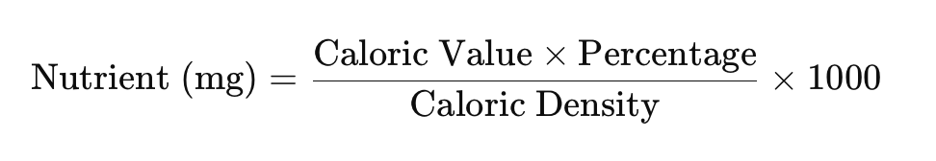

Figure 2.2. Conversion Formula from Caloric Ratio to Milligram Intake

Thus, I converted the calorie contribution to milligrams by applying the known calorie density: 9 kcal/g for fat, 4 kcal/g for carbohydrates and sugars. The result was then multiplied by 1000 to express the value in milligrams. For nutrients that are mentioned only once in a single document, I will default to using that number as the recommended value without dividing by the average, or for nutrients such as water that are hardly mentioned in any document, I will default to not limiting the absorption of that substance because if absorbed in large amounts, it will not significantly affect health, such as doctors always advise patients to drink a lot of water (Appendix E).

## 2.3. Technical Background

### 2.3.1. Content-based Filtering

Modern recommender systems use CBF as their main recommendation method because it examines the technical content features of objects to generate personalized results for each user (Mouhiha, Oualhaj and Mabrouk, 2024).

A recommendation method built using the technical principle uses user profiles constructed from their past engagement activities including product ratings and article consumption (Figure 2.3). The system uses this profile to compare with the content profiles of new items, to determine the level of relevance between the user and each object.

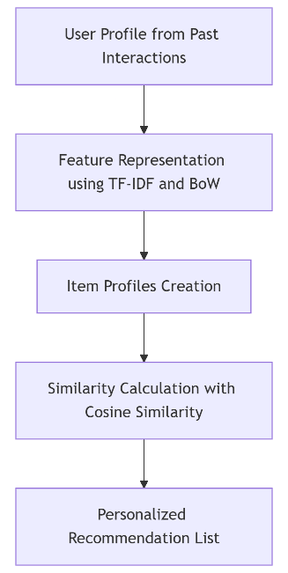

Figure 2.3. Content-Based Filtering Process Flow

In the Feature Representation process, each item is converted into a vector of attributes. For example, movies allow users to identify them by examining genres (action, comedy, romance) or determining directorial involvement or key actors or reviewing their script descriptions. BoW and TF-IDF algorithms function as popular encoding methods that transform textual data into numerical vectors so that comparison and calculation become feasible for the system.

The first step of Item Profile Creation requires a thorough evaluation of all item contents, including unique profile, storing information such as keywords, genre, author, or technical specifications. In the case of e-commerce or e-learning systems, the profile may also include difficulty, prerequisites, or document format.

After the user and object profiles are built, the system performs Similarity Calculations to determine the degree of similarity between the user and each item. Cosine similarity functions as the primary method to find the angle between two vectors positioned in a multidimensional space (Parthasarathy and Sathiya Devi, 2023). The formula for calculating cosine similarity is defined as follows (Figure 4-5):

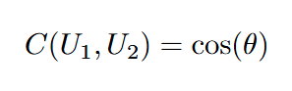

Figure 2.4. General Formula of Cosine Similarity

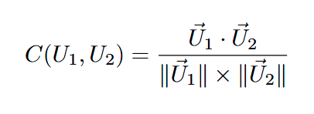

Figure 2.5. Vector-based Cosine Similarity Formula

Where A and B are two vectors representing the user profile and the item profile. The closer the cosine similarity value is to 1, the more similar the product and user preferences are.

In summary, CBF provides an approach that focuses on users’ individual preferences, allowing the system to recommend products that are “content-similar” to their previous consumption history. However, the major drawback of this method is that it leads to over-specialization effects and difficulty extending to novel content that users have not interacted with.

### 2.3.2. Machine Learning

Modern intelligent systems establish ML as their base foundation that guides the solution of complex problems in current times. Fundamentally, ML operates as learning libraries that automate model building tasks to solve analytical problems through data-based processes (Janiesch, Zschech and Heinrich, 2021). The ability to produce personalized products through tailored recommendations is essential for recommendation systems that operate in various industry sectors (Figure 6).

Figure 2.6. Conceptual Hierarchy of Machine Learning, Shallow Learning, and Deep Learning  
 (Janiesch, Zschech and Heinrich, 2021)

The implementation of analytical model building methods through explicit rules and logic presents problems for the flexible and efficient handling of user preferences and operating environments' complexity. Through automatic pattern detection, ML creates fundamental changes that ease the process of rules development. The set of ML algorithms performs analysis of information to recognize patterns, which enables them to generate forecasts and suggest options.

Multiple machine learning approaches prove directly applicable to the development of ideation systems. For instance, the use of multiple decision trees yields the Random Forest algorithm (Figure 7) as an advanced learning model that generates accurate predictions (Chen and Ishwaran, 2012). Random Forest performs best with complex data that contains a great deal of variation because it generates high accuracy by using combinations of decision trees. The ability to handle high-dimensional data is particularly beneficial in ideation systems, where user preferences and item characteristics may be related to many valuable factors.

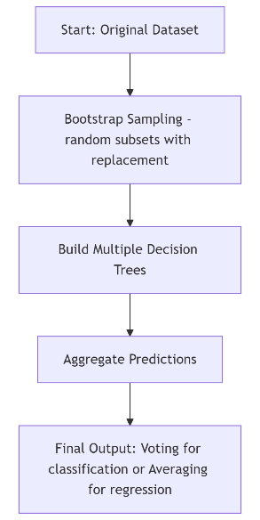

Figure 2.7. Workflow of Random Forest algorithm using bootstrap sampling and aggregation

Various other machine learning algorithms function along with them. Deep learning models along with neural networks demonstrate valuable characteristics for many applications because they tend to excel over traditional learning models. The advanced data processing capabilities of deep learning recommend it as an ideal method for detecting intricate patterns in the relationships between system users and content in ideation systems. Conversely, the Logistic Regression algorithm is a transfer system for binary outcome analysis, but it shows potential in recommendation problems by determining user-item interaction likelihoods (LaValley, 2008).

The selection of an algorithm for recommendation systems demands an examination of distinct operational and conceptual attributes of the task at hand. Having an outstanding capability for dealing with complex data while maintaining accurate predictions belongs to Random Forest but Neural Networks demonstrate remarkable performance at pattern detection even though their implementation demands extensive data and processing capabilities. Logistic Regression offers an approach that is easier to solve for some of the expected tasks. In addition, except for Random Forest, the two other approaches also require a separate pre-processing standard for the data. This can cause some challenges in the training and evaluation of the complex dataset.

In short, the development of system recommendations has experienced a revolution through ML algorithms that allow data analysis to create customized export problems and solutions. The benefits of Random Forest, Neural Networks and Logistic Regression algorithms create progressively complex and efficient tip platforms because of their distinct abilities. Therefore, as a developer, I must spend time on researching to use an optimized algorithm for this thesis.

### 2.3.3. Emotion Recognition Approaches

There are many different methods to determine a person's mood, hence, I needed to consider and compare two main approaches that are suitable for a person with no psychological or medical expertise like me.

Since I originally planned to build a mobile application to be able to determine mood, I planned to apply the MFQ questionnaire - a validated questionnaire in psychology that can be easily accessed for free. However, to ensure the user experience of the application, I planned to use a short questionnaire consisting of only 13 simple multiple-choice questions that can only be answered true (0), false (2), sometimes (1) to calculate a score to determine mood. However, according to the research report on MFQ, the above questionnaire can only support me in calculating the score for depression, anxiety, anxiousness but does not give me a specific scale for each mood. At the same time, after studying them more closely, this method still cannot determine the mood from neutral to positive states (Schlechter *et al.*, 2023).

Instead, the alternative option I proposed was to use a pre-trained model on Hugging Face, which is capable of classifying emotions from facial selfies. Firstly, my decision to not train an AI model to classify emotions from images but just apply an existing model because this was not the main goal I aimed for this project. It also helps me optimize the time to complete this project. Finally, detecting a person's mood without the help of psychologists could consume too much time in the process of collecting data and training this model. In addition, due to the model's lack of accuracy, from a medical perspective, it could also reduce the performance of the primary model deployment process for this project (Jain, Shamsolmoali and Sehdev, 2019).

## 2.4. Related Work

The Mood-Based Food Recommendation System developed by researchers at Sreenidhi Institute of Science and Technology focuses on suggesting dishes and restaurants based on users’ moods (Gupta *et al.*, 2021). The system uses K-Means clustering for location-based restaurant grouping together with collaborative and content-based filtering methods in their recommendation process. Using pre-set mood choices users can initiate the system which supplies food recommendations together with popular ratings and restaurants in their vicinity. Moreover, the integrated method in my project deploys an AI-operational facial emotion recognition model to automatically extract users' emotions from pictures instead of depending on person-to-person input. My project deploys the Random Forest algorithm to evaluate nutritional ingredients for mood compatibility while their system places importance on restaurant ratings and location; indeed, my work focuses on mood-optimizing nutritional meal recommendations. At present their web-based platform leverages Flask and PyCharm whereas my mobile application solution implements React Native with Flask to deliver a user-friendly interface to users. In conclusion, my work is different from their system because it selects health-conscious meals that match users’ nutritional requirements and emotional needs by using scientific approaches to mood-based dietary guidance.

# Chapter Three – Methodology

## 3.1. Methodology Overview

In this chapter, I present the entire methodology that I used to develop a food recommendation system based on user emotions using AI technology. The procedure contains three fundamental components, starting with user requirement definition and proceeding to model design and experimental model configuration. First, I conduct an analysis and classification of functional and non-functional requirements based on the MoSCoW method and identify stakeholders to ensure that the system meets the original goals. Next, the system consists of two main elements, which I explain in depth: the emotion recognition model and the algorithm determining emotional state compatibility with nutrient types. The last stage involves designing experimental tests to evaluate the model and selecting a suitable algorithm for implementation, as well as constructing a training dataset.

## 3.2. User requirement

### 3.2.1. Functional Requirements

Functional requirements define the core operations that the mood-based food recommendation system must perform. The system requirements stem from its Chapter One-described intended use and enable user experience and data processing while enabling personalization logic. This system requires the following essential functions (Table 3.1):

Table 3.1. Functional Requirements

|  |  |
| --- | --- |
| ID | Requirement |
| FR1 | The system shall allow the user to upload a facial image for emotion detection. |
| FR2 | The system shall detect the user's emotion using AI model. |
| FR3 | The system shall recommend a list of foods based on detected emotion, meal type, and age group. |
| FR4 | The system shall retrieve food nutritional information from a local dataset. |
| FR5 | The system shall provide explainable reasoning for each food recommendation. |
| FR6 | The system shall allow the user to rate recommended foods to improve personalization. |
| FR7 | The system shall save interaction history per user to support future enhancements. |

### 3.2.2. Non-Functional Requirements

The system achieves effective performance through non-functional requirements alongside secure and reliable operation. The project requirements cover system speed, user experience, together with expansion capabilities and data protection measures. This presents the key non-functional requirements (Table 3.2):

Table 3.2. Non-Functional Requirements

|  |  |
| --- | --- |
| ID | Non-Functional Requirement |
| NFR1 | The system will respond to user emotion detection and food recommendation immediately. |
| NFR2 | The user interface shall be optimized for mobile use via a responsive React Native application. |
| NFR3 | The food recommendation model shall achieve at least 80% Top-1 Accuracy on a reduced test set. |
| NFR4 | Users shall have their information saved in secure methods through anonymized procedures. |
| NFR5 | The backend system shall support scalable deployment for future integration with restaurants. |
| NFR6 | The system shall provide **transparent explanations** for food suggestions through Explainable AI. |

### 3.2.3. Stakeholder Identification

Identifying stakeholders is essential to ensure that the development of the mood-based food recommendation system aligns with the needs and expectations of all relevant parties (Table 3.3). Stakeholders take diverse parts throughout the project duration because they affect important decisions from requirements identification to systemic assessment and long-term adaptability evaluations. The definition of stakeholder expectations should direct how features get prioritized, since it enables solutions to remain technically competent while maintaining user orientation. The key participants for this project include the following entities:

Table 3.3. Stakeholder Identification

|  |  |  |
| --- | --- | --- |
| Stakeholder | Role | Needs and Expectations |
| End Users | Individuals seeking food suggestions based on mood | Users can access accurate food recommendations, which are delivered at high speed through personalized mobile interface services. |
| Application Developers | Builders and maintainers of the system | The system possesses clear specifications of necessary features and non-functional needs with scalable and manageable backend systems. |
| System Administrators | Manage system security, updates, and maintenance | User data needs secure storage, while the system requires high availability of services. |
| University Supervisor | Academic oversight and evaluation | The project needs to fulfill requirements using the selected methodology while maintaining standards of academic achievement in all areas. |

### 3.2.4. MoSCoW Prioritization

System functionalities and development tasks receive their priority through the implementation of the MoSCoW method (Table 3.4). The method establishes four groups to arrange system needs starting from Must Have to Won't Have. The approach guides the development of tasks according to essential goals while keeping pathways open for future improvements and development. The following table presents an overview of the selected features that will be developed for the mood-based food recommendation system:

Table 3.4. MoSCoW Prioritization

|  |  |  |
| --- | --- | --- |
| Priority | Feature | Description |
| Must Have | User mood survey | The analysis of emotional state requires mood data collection from a trained model. |
| AI-powered food recommendation | Through Random Forest the system offers recommendations that consider both mood and nutritional content. |
| Mobile app interface (React Native) | Basic UI with authentication, recommendation screen, and mood history. |
| Backend API (Flask) | Connect frontend and AI model; retrieve food suggestions via API. |
| Model evaluation | The AI system should be assessed by accurate metrics and feedback data. |
| Should Have | User behavior learning | The system should modify its recommendations through evaluation of user mood patterns together with their preference records. |
| Social media login | The system supports Google and Facebook authentication options to give users easier access. |
| Multilingual support | Provide multi-language interface to reach a broader audience. |
| Could Have | Customizable UI/UX themes | Users should have the option to personalize their interface by choosing dark mode with selectable color options. |
| Seasonal food recommendations | The recommendation system should adjust its suggestions according to which foods are available seasonally. |
| Personalized meal planning | The system will produce weekly meals from tracking user emotional tendencies. |
| Won’t Have | Psychological diagnostics | The app will not interpret mood data for mental health diagnostics. |
| IoT/biometric integration | The system does not connect to smartwatches and biosensors because implementing these features increases technical complexity. |
| Daily long-term meal plans | The application provides quick food recommendations instead of planning future eating sessions.. |

### 3.2.5. Use Case Diagram

In the use case diagram, within the system two primary interacting entities exist as Users together with Administrators (Figure 3.1). I designed core functions for users including registration, login, taking emotion recognition photos, setting food preferences, getting recommendations, and evaluating results. Through my work I established functions which enabled administrators to both analyze food choosing trends as well as handle user management responsibilities. Required functions were represented through "include" relationships while "extend" relationships showed optional extensions so it became easier to understand both the system's sequence and different functional relationships.

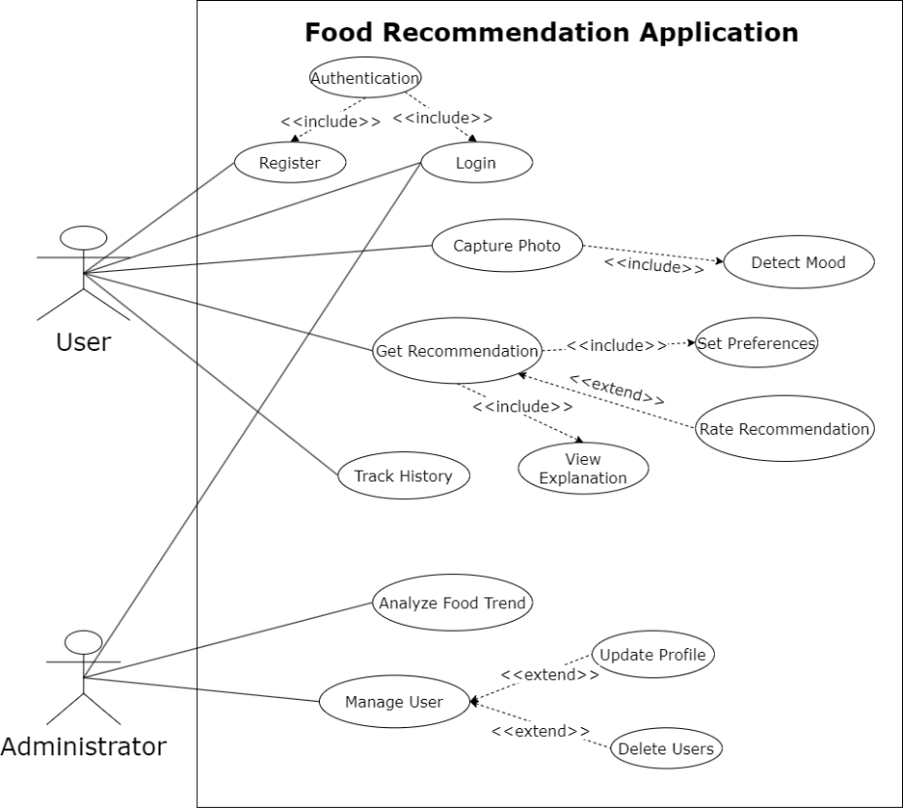

Figure 3.1. Use Case Diagram

## 3.3. Model Components and Approaches

### 3.3.1. Facial emotion image detection

The emotion detection model ***(dima806/facial_emotions_image_detection)[1]*** that I have chosen to apply to my project has been developed in a comprehensive and systematic process. After learning about the model through its description. This process begins with collecting and processing facial image data that represent different emotions and they are organized into training sets with clear emotion labels such as "happy", "sad", "angry", "fear", "surprise", "disgust" and "neutral".

During the data preprocessing process, they normalized the images through techniques such as cropping and resizing, normalizing the brightness, and applying random transformations (such as rotation, flipping, sharpening) to enhance the diversity of the data. This helps the model learn features that are invariant to small changes in shooting conditions.

In addition, when training the model, they applied the previously trained VIT architecture with the identifier ***(google/vit-base-patch16-224-in21k)***[2]. This model was fine-tuned on a facial emotion dataset with 7 different emotion classes. The model reached 91% accuracy after 25 training epoch applications (Figure 3.2-3.3). Furthermore, the confusion matrix code shows that the model works well on all 7 types of emotions, especially the emotions "disgust" and "surprise".

Figure 3.2. Facial Emotion Image Model Classification Report

Figure 3.3. Facial Emotion Image Model Confusion Matrix

### 3.3.2. Compatibility score evaluation

This method seems to be the core method for my thesis this time, synthesizing scientific studies on important nutrients for each mood, from which I proceeded to build food selection rules.

At first, I established the relationship between emotional states and appropriate nutrients with personalized nutritional needs by determining a list of priority nutrients for each emotion such as "sad", "happy", "angry", "disgust", "neutral", “fear” and "surprise" (Appendix D). For example, for the sad state, the system prioritizes foods rich in polyunsaturated fatty acids (omega-3), vitamin D, B vitamins and magnesium.

After determining the priority list, a weighting system helped identify the significance of different nutrients for my evaluation. The priority nutrient, which received Number one, earned the highest weight value of 1.0, while the remaining nutrients received decreasing weights ending at 0.1, resulting in a linear weight distribution. This number was then normalized by dividing the total to ensure that all contributions equaled 1 (Figure 3.4).

Figure 3.4. Priority Weight Normalization Process

After that, I performed the calculation process by determining the nutritional recommended daily intake for each age group (Appendix E). For each nutrient in the priority list, the system compared the actual nutritional value of the food to the ideal value that had been determined for the corresponding age group. The ratio between the actual value and the ideal value was then used to calculate a suitability rating factor. This approach helped me because it handled the variance based on the degree of deviation from the ideal value.

Specifically, if a food contains more than twice the ideal value for a nutrient (ratio > 2), the system applies a decreasing penalty according to the formula (Figure 3.5): factor = max(0, 1 - (ratio - 2) / 3). The scoring system prevents foods with very high nutrient content from obtaining high scores because excessive nutrition is not beneficial. However, the penalty is less severe when nutrient content falls below 10% of recommended values, which leads to factor = ratio * 2. For values ​​within the appropriate range, the factor is calculated as 1 minus the relative deviation from the ideal value: factor = 1 - min(1, |actual value - ideal value| / ideal value).

Figure 3.5. Nutrient Suitability Factor Evaluation

The methodology calculates nutritional points, which involves the combination of standardization weight and rating factor, followed by a 10 times multiplication to establish an understandable scale. The overall compatibility rating results from summing all points that each priority nutrient contributes to the score (Figure 3.6). The algorithm generates a number between 0 and 10 that measures food suitability according to the user's emotional situation. A higher score indicates should score better when their foods show improved compatibility.

Figure 3.6. Total Compatibility Score Computation

Finally, the scoring process under this assessment evaluates nutritious elements in foods based on their composition against standard dietary recommendations. Such precision enables recommendations suitable for each user’s emotional situation alongside their age requirements and nutritional specifications.

## 3.4. Experimental Design & Setup

### 3.4.1. Experiment Objectives and Evaluation Metrics

#### 3.4.1.1. Experimental Objectives

These experiments of building a food recommendation system based on the user's emotional state was carried out through a comprehensive machine learning model development process, with Random Forest as the main algorithm (Vaishnavi *et al.*, 2024). Therefore, I conducted a thorough research and implementation process to create a system that can analyze the correlation between emotions and nutritional needs based on scientific grounds. From the application of the model to identify emotions through selfies that I mentioned above, only seven types of emotions (‘sad’, ‘happy’, ‘angry’, ‘disgust’, ‘neutral’, ‘angry’ and ‘surprise’) can be confirmed, along with the method of food recommendation based on the compatibility score mentioned in the previous heading.

I chose the Random Forest algorithm over other algorithms such as SVM, Neural Networks or KNN for several reasons (Martinez-Gorospe *et al.*, 2021). Firstly, the Random Forest algorithm processes non-linear data samples alongside diverse variable relationships without complicated preprocessing. Secondly, Random Forest provides better transparency than Neural Networks because it shows feature importance through which users can comprehend the model's decision-making process across its execution. Thirdly, the processing of categorical variables remains straightforward through Random Forest since it does not need complex one-hot encoding techniques. Additionally, the model demonstrates resistance to outliers in addition to handling noisy data without a data normalization stage while effectively working with highly correlated features – traits that frequently exist in nutrition datasets.

This experiment was designed with clear quantitative and qualitative objectives to ensure the effectiveness of the emotion-based food recommendation system. The main objectives include: achieving accuracy above 80% after the validation process of the Random Forest model; generating recommendation results similar to the traditional compatibility score method, ensuring the consistency and reliability of the system; ensuring that the model accurately handles most possible cases from the input data (different types of emotions, ages, meal types, and food types); developing and integrating personalization elements. Finally, the collection of comprehensive data will create a solid base for researchers studying food and nutrition on moods, which promotes the future development of this system.

#### 3.4.1.2. Evaluation Metrics

A comprehensive evaluation of the recommender system utilizes standard classification metrics along with overall accuracy measures, confusion matrix data and regression-specific metrics including MSE and R² (Jubeile Mark Baladjay *et al.*, 2023). The combination of these metrics provides an authentic depiction of how the model performs at prediction and how users can practically benefit from it.

A confusion matrix provides detailed insights for classification results through its organization of predictions into True Positive (TP) and True Negative (TN), plus False Positive (FP) and False Negative (FN) categories for precise misclassification diagnosis.

MSE evaluates the squares of average value differences between forecasted and actual readings in regression models, but R² determines the extent to which predictive values match the original data pattern. A predictive model features strong predictive power when its R² value is close to 1.0.

Additionally, feature importance analysis determined the principal inputs that influenced decision-making in classification, together with regression models (Jubeile Mark Baladjay *et al.*, 2023). The classification model depended heavily on features of emotion, age group and meal type, whereas the regression model benefited most from nutrient-specific variables, including protein, sugar and caloric value.

Finally, the defined compatibility scoring function was implemented as a domain logic benchmark to evaluate model outputs according to user dietary targets and mood nutrition alignment. This reference ground-truth assists model accuracy assessment by offering vital information that helps evaluate the match between automated predictions and scoring produced by expert specialists.

### 3.4.2. Experiment A:

#### 3.4.2.1. Date Collecting and Preprocessing

Understanding that data collection and preprocessing play an important role in developing a food recommendation system based on users’ emotional states. I utilized the ***Food Nutrition Dataset*** [3] to obtain 2,395 different food information (Vegesna, 2024). I actively filtered the dataset to 230 items because it enabled me to create specific recommendations for bakeries or café rather than generalized food predictions. In addition, to establish data structure I incorporated a new “Types” attribute which divided the 230 items across four groups: cake, drink, dessert and sweet. Despite the significantly reduced sample size, the greater specificity and homogeneity of the data can still effectively support the applied algorithm in determining the relationship between nutritional content and emotional states, especially in the context of sweet foods. In particular, the above dataset includes important nutritional parameters such as calories, fat, protein, carbohydrates, vitamins and minerals - all of which are key factors in determining the relationship between food and emotional states. In the preprocessing stage, I have given the data several cleaning and normalization steps to ensure the quality of the machine learning model.

#### 3.4.2.2. Recommendation System Approach

In case, the system provides two types of recommendations: mood-optimized (based on emotional state) and personalized (when the user specifies a nutrient they want to enhance), with the latter case enhanced by placing that nutrient at the top of the list and multiplying the overall score for the food by 1.5 times in the priority list as a flexible factor for the model to adapt to produce different results (Figure 3.7).

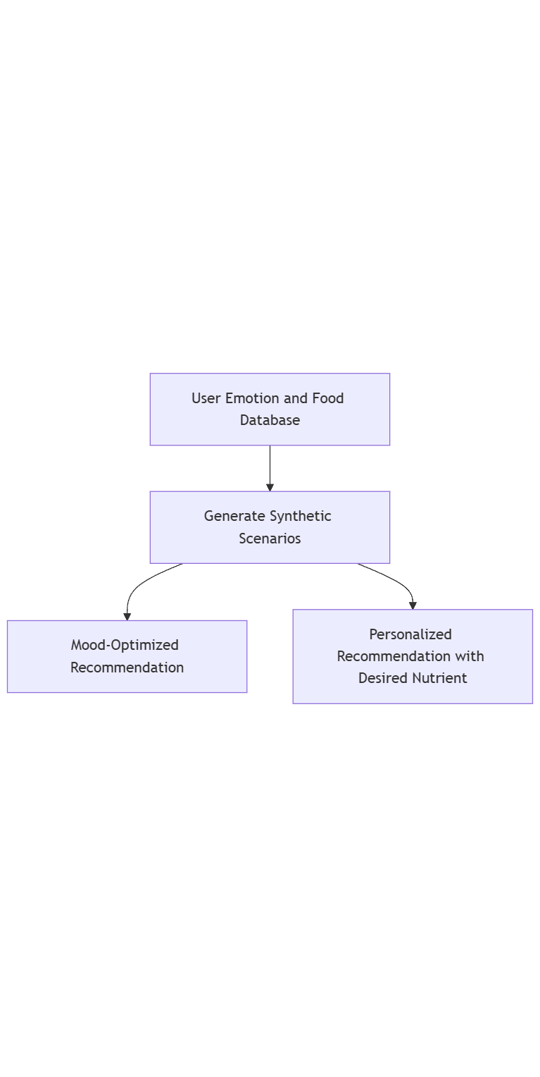

Figure 3.7. Recommendation Approach Flow

In addition to the mandatory step of applying a compatibility score along with nutrient priorities and daily intake recommendations, this experiment from 230 samples of different dishes of the dataset after preprocessing, I generated 2 synthetic datasets for training 2 AI models at the same time. The number of samples in these 2 datasets is not a predefined target but emerged naturally from the synthetic data generation process.

The code generates 1,000 recommendation scenarios and for each scenario, it generates multiple food options with corresponding scores. For the mood-optimized recommendations, this results in about 4 options representing the top 4 foods for each scenario. Personalized for recommendations requires a specific desired nutrient according to the user's personal preferences, resulting in fewer scenarios qualifying as foods for each applicable scenario. Since the more constraints you add, the fewer options qualify. Personalized recommendations must satisfy two sets of criteria (emotional state and specific nutritional addition), so fewer foods qualify than those that only satisfy emotional needs.

The feature generation process dynamically generates relevant features based on the input variables. The mood optimization model must only capture the relationship between emotion, age group, food type, and nutritional content. In contrast, additional features need to be implemented into the personalized model for depicting desired nutritional information using one-hot encoding for each possible nutrient (e.g. “desired_Vitamin_C” and “desired_Protein”) and measures of nutrient boosting effects (e.g. “desired_Calcium_boost”). The feature space expansion for personalized recommendations reaches almost double its initial size due to the inclusion of emotional state and nutritional requirement optimization criteria.

The Random Forest and Gradient Boosting methodologies were implemented to check the performance and accuracy. Training the Gradient Boosting Regressor and two models based on accuracy with the Compatibility score resulted in better performance according to my experimental results. This is because the model learns from the above features to predict the compatibility score by analyzing patterns in the data. Through learning the model understands which nutrients receive priority status for particular emotions (such as Magnesium and Polyunsaturated Fats and Vitamin B for Fear) and which foods offer the best nutritional satisfaction according to age group. The R² score and mean squared error are the measures I used to evaluate the model’s accuracy in conjunction with the direct scoring from the compatibility score.

### 3.4.3. Experiment B:

#### 3.4.3.1. Date Collecting and Preprocessing

Realizing the problem with the first test data, I found another food nutrition dataset, called **Food Nutritional Facts**[4], with 1174 unique food information (Vegesna, 2024). The difference from the previous experiment dataset is that this dataset has 59 columns, which are absolutely divided into more nutrients in more detail than the previous dataset. However, because some nutrients may be considered redundant or different from my research on the relationship between mood and nutrients, I had to filter out columns and rename nutrients to match the previous research, for example, in this dataset, the nutrient column "Folate" will be changed to "Vitamin B11" as in the previous study. Furthermore, the reason I moved the new nutrition dataset is because this dataset already has a "Category Name" column for each dish, making it easier for me to clean and preprocess the data.

Not only that, in this experiment, I used another dataset, named the **Daily Food & Nutrition Dataset**[5]. With 14 columns and more than 10,000 rows, it focuses on the statistics of food selection trends of many users through the columns “Date”, “User_ID”, “Category”, “Meal_time” (Vegesna, 2024).

From the two datasets above, I decided that I needed to have a uniform on the type of dishes that were more diverse than the previous test, including “Meat”, “Fruits”, “Grains”, “Vegetables”, “Snacks”, “Beverages”, “Dairy”. And got about 1157 different dishes with 34 nutrition columns like test A for the nutrition dataset, and 10,000 rows with 4 columns in the user history dataset after completing the clean and preprocess data process.

#### 3.4.3.2. Recommendation System Approach

In addition to the above methods, for this experiment, I also applied the inverse compatibility score calculation method. This method is used to identify foods that are not suitable for a certain emotional state, helping to create adversarial examples for training the machine learning model.

The inverse compatibility score formula starts by identifying all other emotional states other than the current emotional state (Figure 3.8). Then, the system calculates the compatibility score of the food for all other emotional states and takes the average value as above. Finally, the inverse compatibility score is calculated by subtracting the score of the current emotional state from the average of the other emotional states.

Figure 3.8. Inverse Compatibility Score Formula

If a food has a low compatibility score with the current emotional state but a high score with other emotional states, it will receive a high inverse score. These foods will be used as negative examples during training, helping the model to better distinguish between foods that are appropriate and inappropriate for a particular emotional state.

User-specific food suggestions use historical records of their eating habits as part of the recommendation process. The extended compatibility score adds bonus points that stem from previously selected preferences of each user (Figure 3.9).

Figure 3.9. Total Score Including User Preference

In this formula, “user_food_matrix” is ​​a matrix containing information about the frequency of consumption of each food type by each user. If a user frequently consumes a certain type of food, the food of that type will receive bonus points (up to 2 points), increasing the probability of being recommended.

The research includes an essential step of developing synthetic data to train the model system. The system generated 5,000 recommendation scenarios for 1,000 users over a 12-month period. Each scenario consists of 10 different foods in the same context (user profile: emotion, age, meal type, food category) for training sample construction.

The recommendation logic of this project was built by me through a systematic pipeline, converting emotional preferences into ranked food recommendations. To train effective models, the business requires three critical steps: nutritional threshold validation, relevance scoring and contextual data labeling (Figure 3.10).

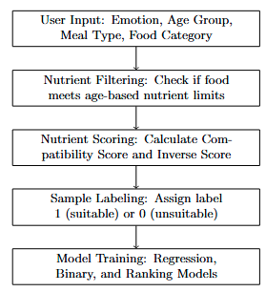

Figure 3.10. Food Recommendation Pipeline

Each training sample is generated by randomly selecting user input that includes the exact possible emotion obtained from the facial detection model mentioned, age group (adult or child), preferred meal type (breakfast, lunch, etc.), and food category (vegetable, snack, etc.). These attributes form the complete user input context for generating recommendation scenarios. The system filters foods that meet the nutritional limits for the user's age group. For each valid food, the system calculates both a compatibility score and an inverse score. The system selects good foods with high compatibility scores and bad foods with high inverse scores. A combination of food items follows a ranking process that determines their score levels of compatibility. The system assigns a binary label, with 1 for suitable food and 0 for bad food. Training the model on a combination of positive and negative cases allows improvement of its discrimination capabilities along with recommendation accuracy.

All nutritional values ​​are also standardized using StandardScaler to ensure that absolute differences between nutritional indices do not distort the training process. The system will produce interaction features to analyze "interaction_sad_Vitamin_D" alongside other emotional and nutrient relationships for nutritional requirement evaluations. Applying the encoding system to user historical data enables mining personal preference features. By organizing various relationships within the dataset, the model achieves a high capability to produce accurate individualized meal recommendations.

Next, the system conducts training on three Random Forest models for separate execution purposes. First, A regression model forecasts the compatibility score as the evaluation of food compatibility with user emotions and nutritional needs based on continuous measurements. Second, the model performs a ranking to determine food preference rankings among foods. Finally, a binary classification model to predict whether a food is suitable or not on a binary scale.

The research makes its significant contribution through an evaluation method that unites predictions from three models with computed compatibility scores. An effective recommendation solution has been built using machine learning methods and scientific knowledge calculations of compatibility scores. In addition, the models are evaluated on the test set using task-specific metrics such as:

* Regression models: MSE and R²
* Ranking models: MSE and R²
* Binary classification models: Overall Accuracy

The proposed system differentiates from other Random Forest-based food recommendation systems through its novel aspects that improve user-personalized recommendations and adaptability. Other research relies on static predictor factors like BMI, allergy data, or diabetic level classification (Martinez-Gorospe et al., 2021; Bungay et al., 2024). In contrast, our system distinguishes itself through its capability to analyze detected emotions along with user age groups, along with contextual food preferences to determine immediate user needs during real-time operations. Furthermore, our approach generates synthetic training data to simulate varied user scenarios because it utilizes an ensemble of regression and binary classifiers and ranking models (for compatibility score, good/bad match and top-N selection). Better robustness together with interpretability, benefits from the integration of multiple models. The system provides a better selection of top-N choices without disrupting nutritional compatibility with emotional requirements.

## 3.5. System Design

### 3.5.1. System Architecture Diagram

I applied the MVC model to separate the functional layers in the system architecture diagram (Figure 3.11). The development of the interface layer used React Native for its ability to support both Android and iOS deployment. The Flask framework managed API requests within the control layer and SQLAlchemy fulfilled business logic as well as database connections in the model layer. I also separated the emotion recognition service into an independent microservice for easy expansion and upgrade. The framework provides flexibility and simplicity during maintenance and scale-up of user requirements.

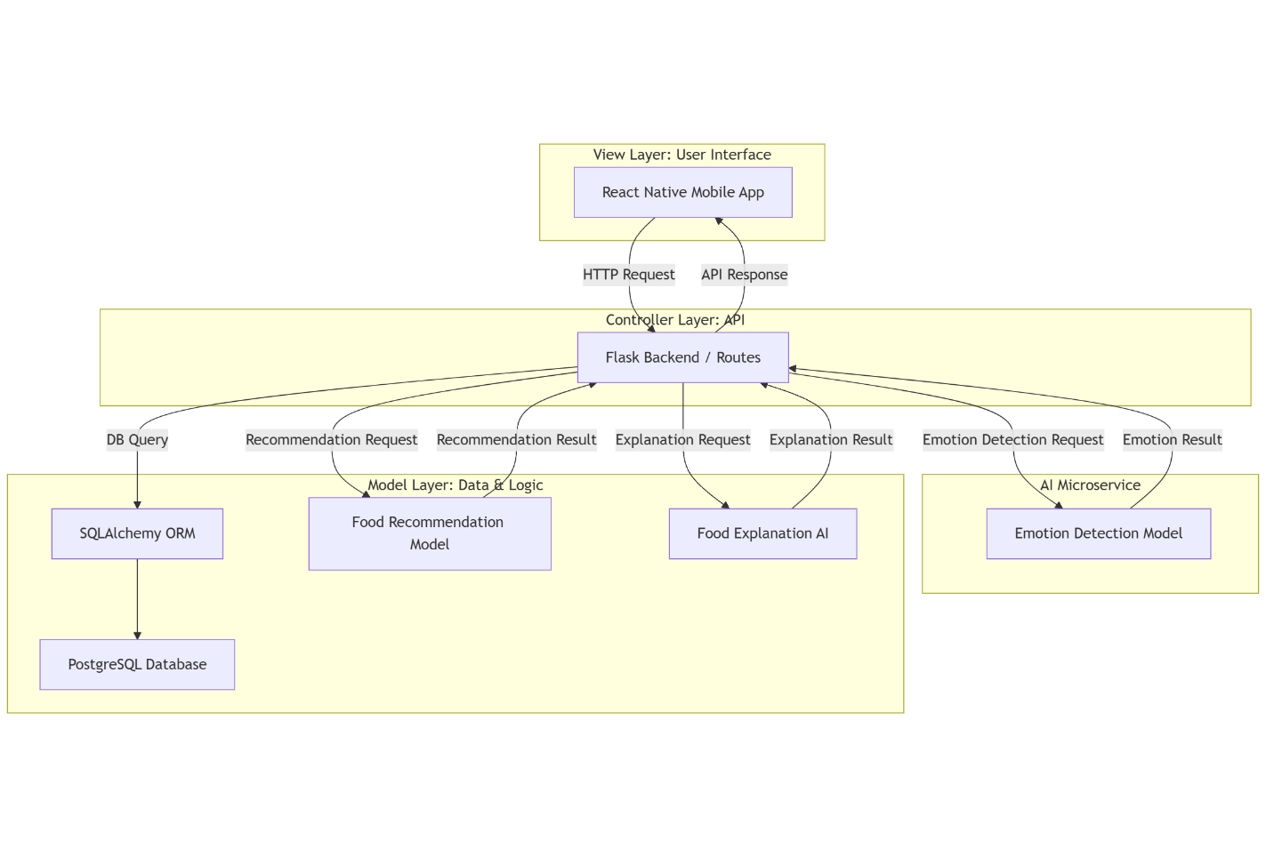

Figure 3.11. System Architecture Diagram

### 3.5.2. Relational Database Diagram

I designed a relational database diagram (Physical Database Diagram) to describe the database structure (Figure 3.12). The User table stores user information with fields such as “id”, “name”, “email”, “password_hash”, and “role”. The “UserFoodLog” table contains details about food recommendations, including “mood” (emotion recognized), “meal_time”, “food_type”, “recommended_food”, and “feedback_rating”. The relationship between the two tables through the “user_id” foreign key allows me to easily query the recommendations of each user. Analysis of food sentiment trends becomes possible because this design structure protects the quality of stored data.

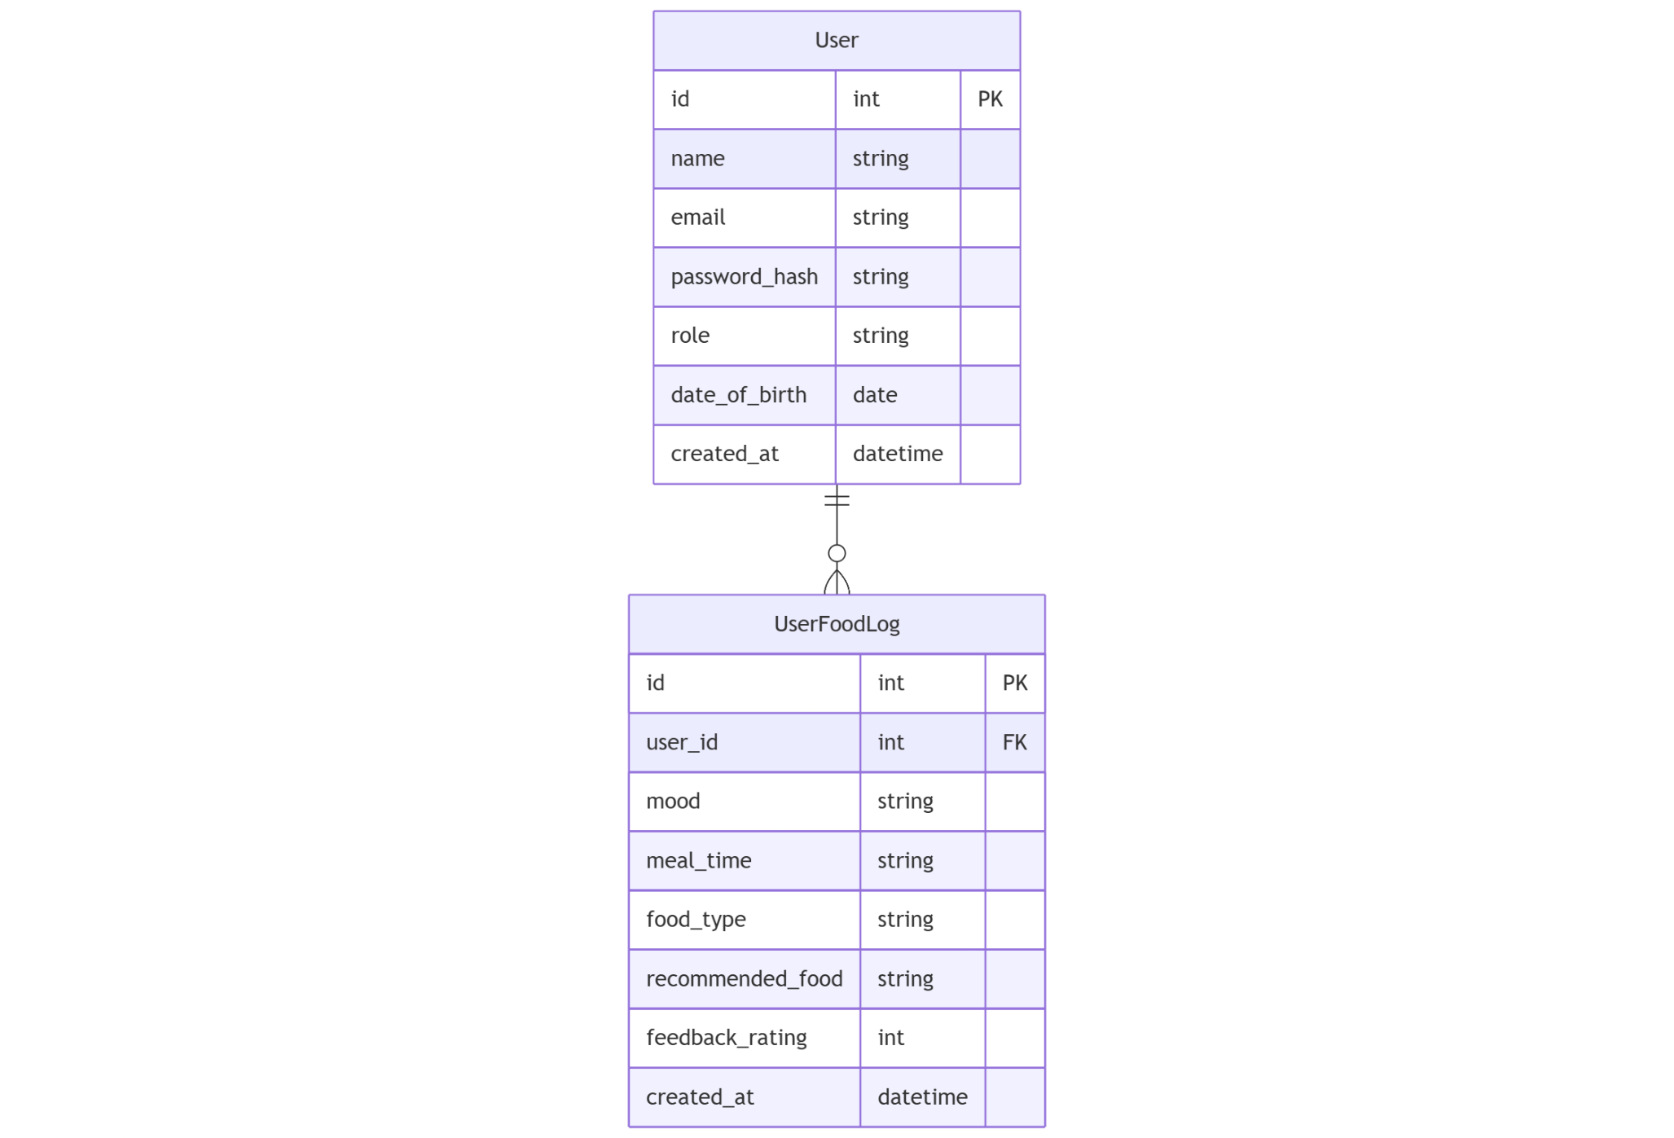

Figure 3.12. Relational Database Diagram

### 3.5.3. Class Diagram

For the class diagram (Figure 3.13), I focused on two main classes: “User” and “UserFoodLog”. The User class contains personal information and authentication methods, while “UserFoodLog” stores the recommendation and review history. I added important API methods to both classes, such as “register” and “login” for “User”, and “detect_emotion”, “recommend_food” for “UserFoodLog”. The one-to-many relationship between the two classes is represented by the diamond symbol at the beginning of “User”, indicating that a user can have many food records. This design makes it easy for me to expand and maintain the system in the future.

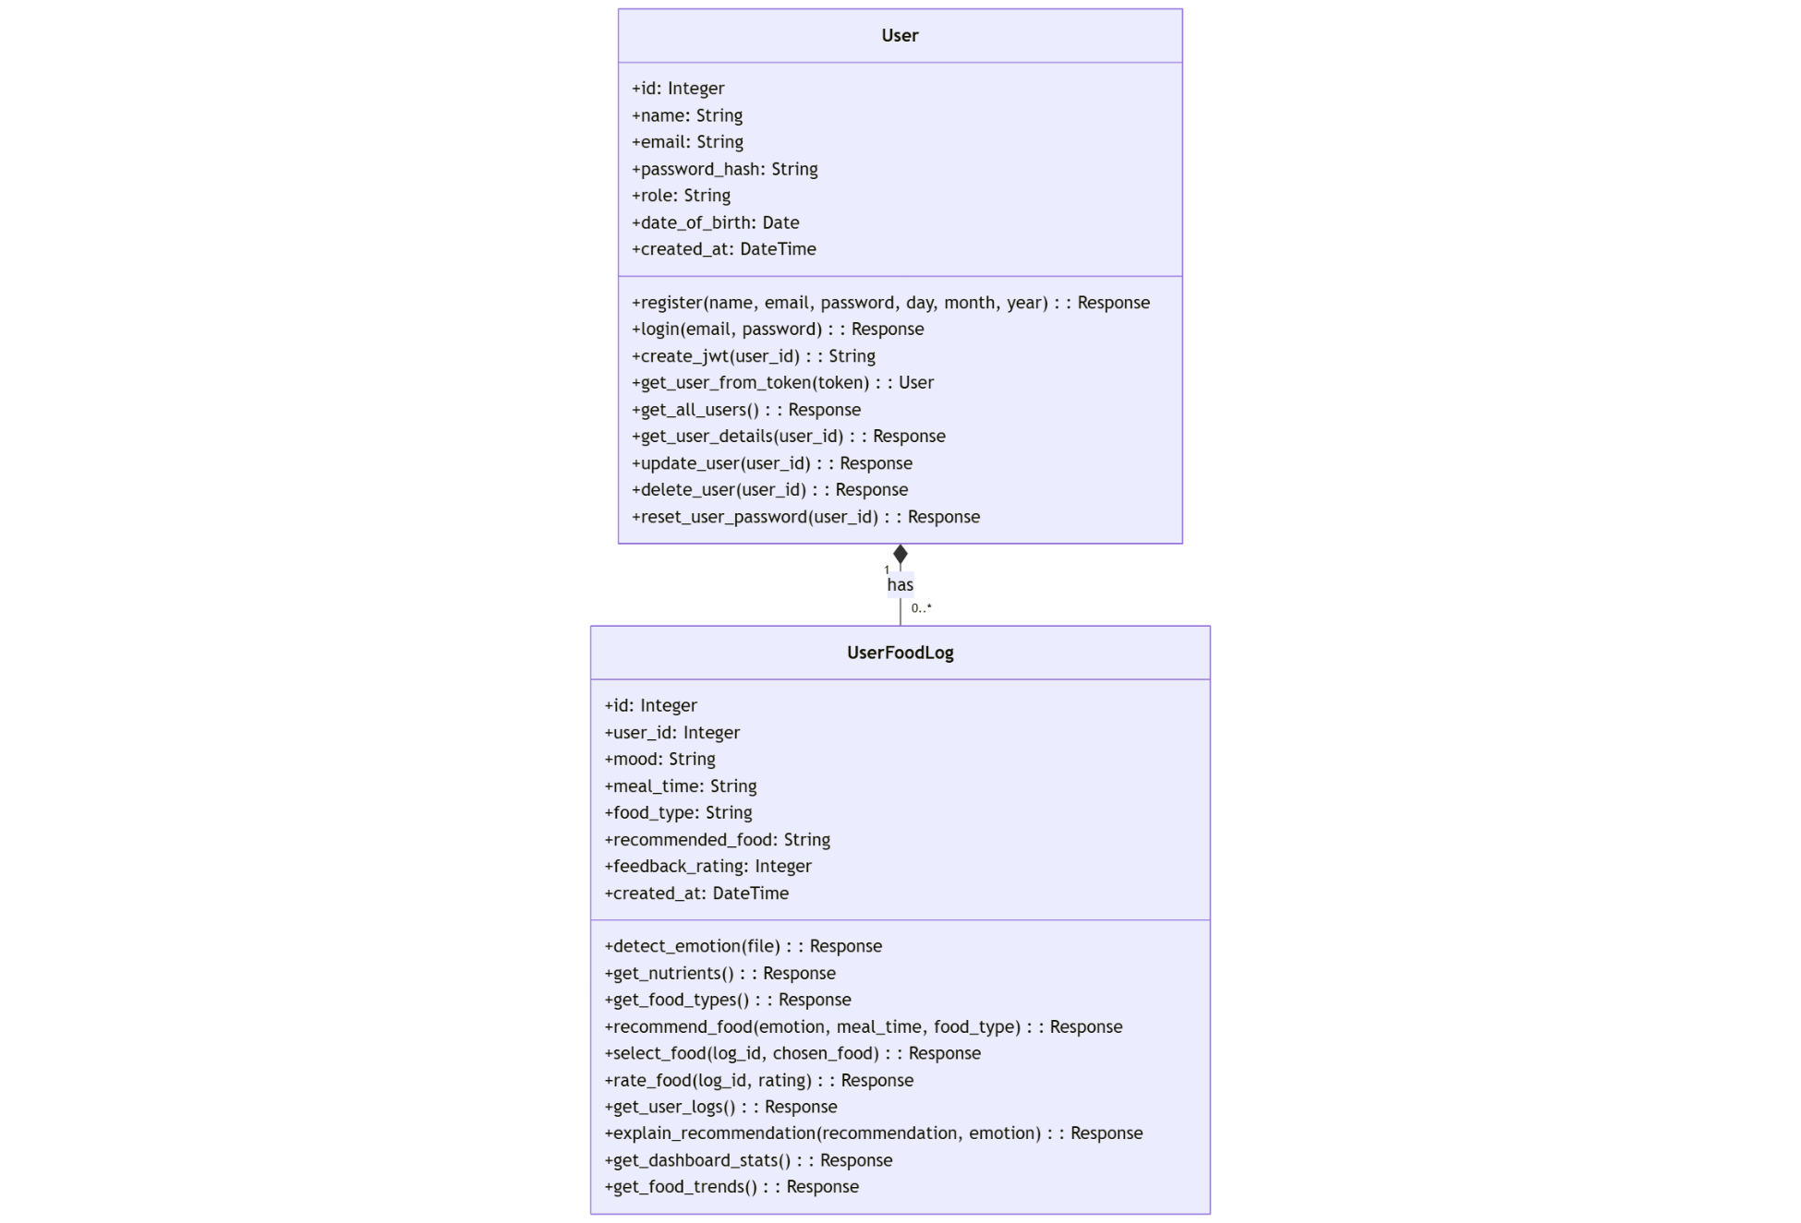

Figure 3.13. Class Diagram

### 3.5.4. Sequence Diagram

The system's interaction with users receives a detailed representation through my sequence diagram design (Figure 3.14). In this diagram, I clearly show how the user goes from logging in, taking a photo for emotion recognition, to receiving and rating food recommendations. I implemented “Alt” blocks to deal with situations that included both failed logins and situations where no suitable recommendations could be generated. Such a design allows the app to handle every scenario while delivering consistent user experiences along with clear data flow management within system components.

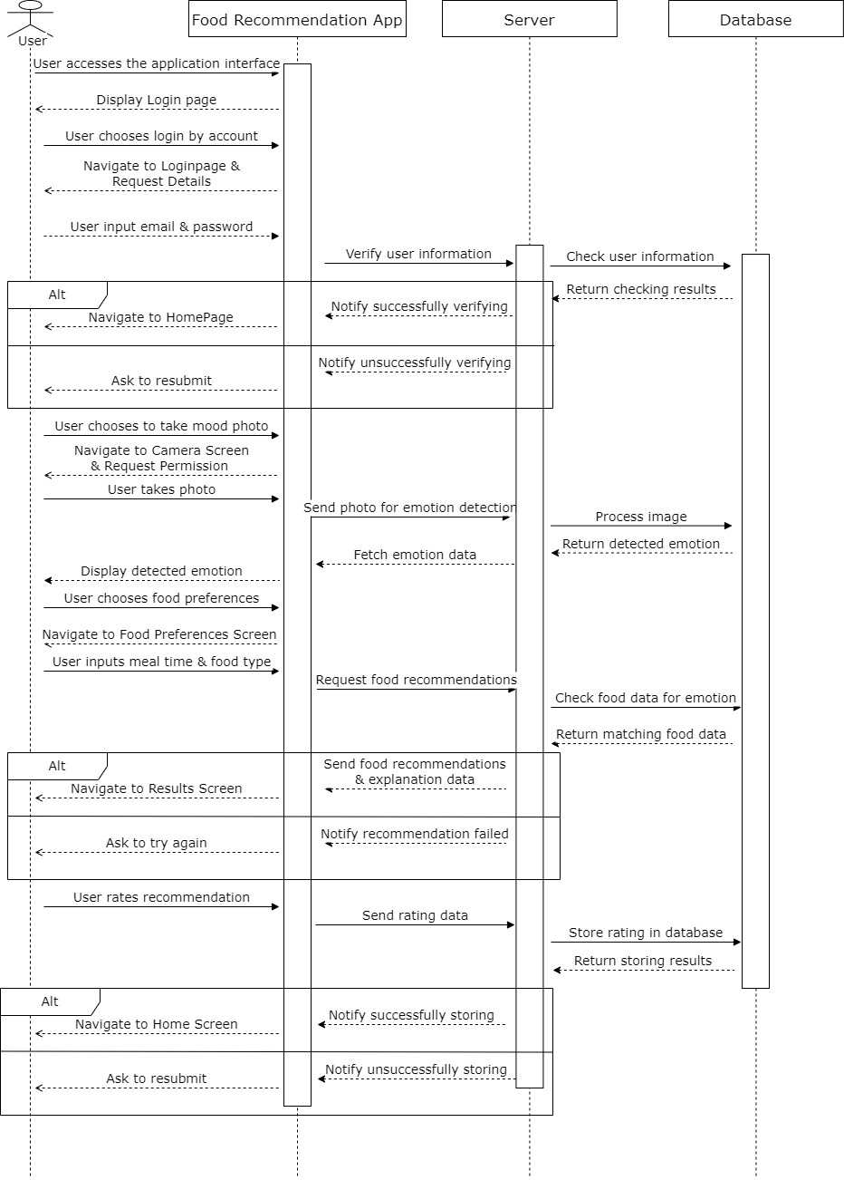

Figure 3.14. Sequence Diagram

### 3.5.5. UI/UX Design

After several ideas emerged in my mind, I started drawing preliminary hand sketches as my first stage in designing the app's UI/UX. The application development process permitted me to evaluate various layout structures and user interactivity designs at this point. After finding promising directions, I proceeded to start digital wireframing. During this phase, I independently designed both the information structure and fundamental app interaction patterns to guarantee smooth logical use. Finally, I gave the wireframe a visual, dynamic look in Figma. The interface development included my personal selection and strategic arrangement of every color and font, along with icons to create an elegant design that also ensured the optimal user journey (Figure 3.15).

[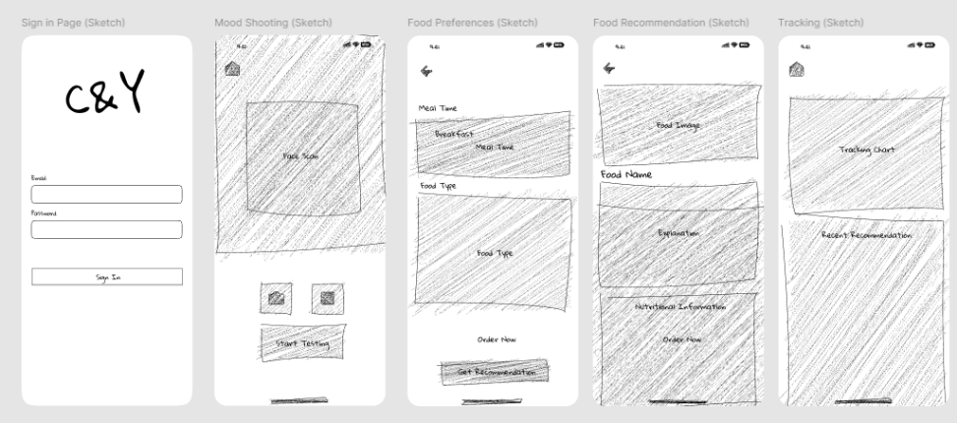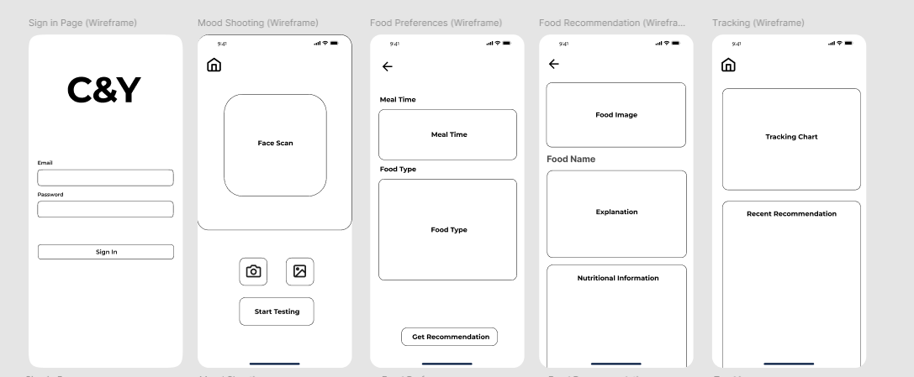](https://www.figma.com/design/l8GAuWvS0V0Ai6oKSzjAUd/UI-UX-Application?node-id=0-1&t=EEleDz2mK9vebqUm-1)

Figure 3.15. UI/UX Design

# Chapter Four - Implementation

## 4.1. Implementation Overview

During my thesis, I implemented the entire food recommendation system based on user emotions by combining various technologies. First, the training model required a normalization process after preprocessing the nutritional data for consistency during the operation. Next, I built and trained machine learning models, in which the Random Forest model was mainly used to predict the compatibility score between food and emotional state. In addition, I built both a mobile application based on React Native for user system interaction, along with a Flask-powered backend API to manage application requests. Finally, I tested the entire system, evaluated the model performance, and optimized the functions to ensure smooth and accurate operation (Appendix F).

## 4.2. Experiments Implementation

### 4.2.1. Experiment A Implementation

#### 4.2.1.1. Data Processing Implementation

Firstly, the dataset is comprehensively inspected through methods such as “df.info()” and “df.describe()” to understand the structure and distribution of the data. The results show that the dataset consists of 37 columns with different data types (int64, float64, object) and no missing values.

Next, Unit conversions occurred following the procedure which changed grams (g) into milligrams (mg) measures for nutrients including fat, carbohydrates, protein, and fiber to achieve uniform measuring units. Then, the process of removing unnecessary columns was performed, retaining only 33 important information fields related to nutrient composition and food type.

Subsequently, to prepare for building the ML model, the text data was encoded using the “factorize()” method, creating a "food_encoded" column that converts food names into numeric values. After that, I employed a boxplot to identify outliers in the numeric data for assessing data quality visually, which highlighted the need for normalization, such as Sugars and Sodium (Figure 4.1).

Figure 4.1. Boxplot of nutritional attributes

Finally, the modified dataset is saved as "food_nutrition.csv" so it can advance to the upcoming steps of AI model development. The preprocessing procedures generate structured data that prepares it for building a food recommendation system that personalizes nutritional experiences for users through AI technology.

#### 4.2.1.2. Model Configuration and Training

Two synthetic datasets were derived from the food nutrition database before the model training process started. The mood-optimized dataset contained 4,000 samples which offered individual food suggestions based on emotions but the personalized dataset included 2,720 samples that covered emotional states alongside nutrient requirements.

The mood-optimized model received 57 features, which were developed through meticulous application of feature engineering methods. “Supported_emotions.index(emotion)” indicated the encoded emotion features along with age group encodings through binary child/adult classification and food type encodings obtained from the original dataset and emotion-specific nutrient score features (e.g., “fear_Magnesium_score”, “fear_Vitamin_B6_score”), accompanied by nutritional content normalizations (e.g., “norm_Caloric_Value”, “norm_Protein”). The personalized recommendation model required a more complex feature space with 113 features, including all mood-optimized features plus one-hot encoded desired nutrient indicators (“desired_Vitamin_C”, “desired_Protein”, etc.), nutrient boost effect measurements (“desired_Calcium_boost”, “desired_Magnesium_boost”, etc.), and interaction features between emotions and desired nutrients. The function “prepare_direct_scoring_features()” utilized domain knowledge to create features that considered nutritional needs according to various emotional states.

Scikit-learn executed the Gradient Boosting Regressor model for training purposes. The key components included a configuration with 200 sequential trees, a conservative learning rate of 0.1 to prevent overfitting, controlled tree depth of 4, minimum samples required to split nodes set at 5, minimum samples at leaf nodes of 3, and using 80% of samples per tree for robustness, all with a random state of 42 to ensure reproducibility. The system used a train-test split (80-20) through “train_test_split()” of scikit-learn for model training, while fitting the mood-optimized model with “.fit(X_mood_train, y_mood_train)”, then assessed results via “mean_squared_error”, “R² score” and “mean_absolute_error”. The training optimization function concentrated on reducing the error rate of the compatibility score because it determines how meals meet specific emotional state nutritional needs (Figure 4.2).

Figure 4.2. Pipeline for Mood-Optimized and Personalized Models

After training, the model and its mappings and feature names were serialized using joblib to ensure easy deployment in the recommendation system without additional training sessions. The mood-optimized model showed superb accuracy through its 0.9992 R² score and its low 0.0029 mean squared error value for predicting compatibility scores. The Gradient Boosting implementation showed the personalized recommendation model to achieve R² score of 0.9532 while maintaining a mean squared error of 0.2907.

The direct scoring method produced different results when analyzing the top 4 recommended foods alongside the metrics performance from both models, because of noticeable discrepancies between the outputs. The differences between model outputs indicate that, although mathematically accurate, the personalized model could learn patterns different from direct scoring algorithm priorities.

With the mood-optimized model recommendation results, there are some cases where the results are accurate with the direct scoring method, but not as accurate as the 99% accuracy results when I change the input. With the personalized recommendations results, the difference is even more obvious. The small number of 230 original foods in the sample likely produced overfitting problems. The large number of samples created (2,720) derived from an initial food database (230) could lead the model to learn specific patterns rather than true general relationships, which would then generate dissimilar recommendations when fed with different emotional states. In addition, this model is not practical when applied to a real project when I will definitely limit the amount of food dataset used in the application to demonstrate the ability and value of the AI model when it can learn rather than using the compability score feature directly to recommend, which would go against the purpose of the thesis.

In conclusion, realizing the problem, I will not apply this experiment to my application. However, this experiment can be improved in the future if more focus is placed on expanding the initial dataset to create more diverse training samples.

### 4.2.2. Experiment B Implementation

#### 4.2.2.1. Data Processing Implementation

In the data preprocessing stage, I cleaned and prepared two datasets: food nutrition data and user history data. I started importing the data using the Pandas library and checking the existing columns for the nutrition dataset. Next, I applied the “rename()” method operations for column renaming tasks, especially changing "Food Name" to "food" alongside "Category Name" to "food_type" and converting "Calories" into "Calorie Value". Next, I filtered the required columns by creating a “columns_to_keep” list and using indexes to select important columns.

An important step in the processing was converting the units of measurement from grams to milligrams for nutrients and from IU to milligrams for Vitamin A to ensure consistency. I used a loop to process each group of columns and applied the appropriate conversion factor. For missing values, I used the “fillna(0)” method to fill in the value 0.

For the user history data, I followed the same steps, starting by reading the data and changing the column name "Category" to "food_type" to ensure the best calculation for nutritional data. I then filtered the necessary columns such as "Date", "User_ID", "food_type" and "Meal_Type".

An important part of the process was to normalize the values ​​in the "food_type" column between the two data sets. I verified each distinct value between the datasets and built a matching table for uniting equivalent food types. The different data sets were grouped as follows: mushrooms and greens became vegetables, while seafood united under meat and nuts joined grains. After applying the diagram, I rechecked and filtered the nutrients to maintain the valid "food_type" according to the user's history. The user history data normalization stage was complete, allowing me to check the food consumption patterns by generating visual charts.

Figure 4.3. Meal Type Distribution

The meal types occurred with approximately equal frequency throughout breakfast, lunch, dinner and snack times in the data collection. (Figure 4.3).

Figure 4.4. Food Type Distribution

The food distribution data reveals Dairy and Fruits as slightly more present, yet different categories remain well distributed, which ensures diverse training content (Figure 4.4).

Figure 4.5. Meal Distribution by Day of the Week

The analysis chart shows stability because users consume more on Mondays and Saturdays than on other days throughout the week (Figure 4.5).

The applied normalization technique did not eliminate extreme data outliers in Fat, Carbohydrates and Sugars, which reveals significant variability in actual food data (Figure 4.6).A graph with numbers and lines

Figure 4.6. Nutrient distribution boxplot

In addition, I developed an implementation of the “is_safe()” safety check function to evaluate whether a food item exceeds the nutritional limits for children or adults, based on the previously defined nutritional limits. Finally, the processed data went through CSV file export for additional assessment purposes.

#### 4.2.2.2. Model Configuration and Training

The model configuration and training process play an important role in this food recommendation system. Based on the prepared data, three Random Forest models operate independently as part of the system integration strategy because it deployed to execute specialized tasks. The regression model undertakes training by “RandomForestRegressor” to calculate compatibility scores, which measure food suitability according to user emotional needs and nutrition requirements on a continuous scale. The ranking model receives separate training as “RandomForestRegressor” to enhance its ability to rank food items accurately for determining proper ranking sequences. A binary classification model trained by “RandomForestClassifier” receives training to create an efficient food suitability tester operating on a two-value scale. The models use specific configuration options that deliver peak performance outcomes through their implementation of 200 decision trees and maximum depth of 10 and minimum splitting conditions of 10, but only 5 samples in leaf nodes to achieve both accuracy and stability. In particular, the class balance parameter (class_weight='balanced') is applied to the classification models to handle the problem of data imbalance, ensuring fair and diverse recommendation results (Figure 4.7).

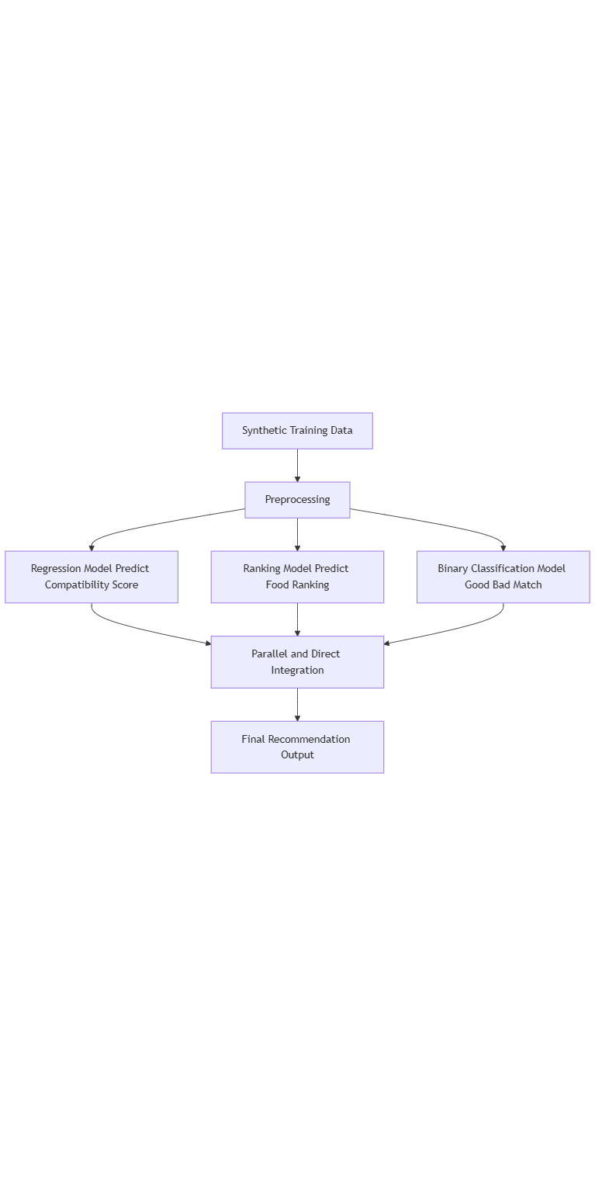

Figure 4.7. Three-Model System Integration

Before training, the data is thoroughly preprocessed. The scikit-learn “LabelEncoder()” transforms categorical variables “meal_type”, “food_type”, “emotion” and “user_id”. The “StandardScaler()” normalization technique scaled the nutrient values so features would be measured consistently on the same metric while keeping the model unbiased. The feature engineering process developed “interaction_emotion_nutrient” features which connect emotion states with particular nutrients while introducing “season_encoded” and “season_emotion” features for annual food consumption patterns.

The training used synthetic data, which originated from the “generate_training_data()” function and included 5,000 samples with ten food items per sample. For evaluation purposes, the “training_test_split()” function divided the data into 80% training data and 20% testing data. The models are trained using the “fit()” method with the feature data “X_train” and the corresponding labels (“y_train_class”, “y_train_score”, “y_train_rank”, “y_train_binary”).

After training, the scikit-learn metrics serve as evaluation tools for the models through “mean_squared_error()” and “r2_score()” for regression and ranking models, together with “accuracy_score()” for binary classification. The “feature_importances_ method” is used to analyze the importance of each feature for each model.

The system also implements the combination of parallel and direct method to integrate the results from three different models. The “create_feature_vector()” function builds the feature vector for new food while “parallel_with_direct_scoring()” unites model predictions from three models alongside direct compatibility scoring to formulate the final recommendation. To evaluate the performance of the system, the “evaluate_on_both_datasets_final()” and “comprehensive_evaluation()” functions are used to test the system on various scenarios.

Finally, user feedback can improve personalized recommendations when using the “get_recommendations_with_user_preferences()” function that implements -1 for dislikes, 0 for neutrality and 1 for likes in food reviews.

.

## 4.3. Mobile application implementation

Technically, the implementation process for my mobile application utilized React Native version “0.79.2” together with Expo framework version “53.0.5” for building a cross-platform application. My use of TypeScript went beyond basic implementation to create data type secure environments and minimize early development errors.

The application architecture is organized by me in a clear layered model. Specifically, the application's interface management lies with the “src/views folder”, while reusable components are stored in “src/components” and API interactions with the backend go through the src/services directory and the “src/styles” maintains interface definitions and the application's global state management occurs in “src/context”. The application uses React Context API with “AsyncStorage” to create “AuthContext” for handling login sessions and JWT tokens.

The application uses React Navigation 7 for navigation control that provides “StackNavigator” and “TabNavigator” to enable both “AppNavigator” (for user access) and AdminNavigator (for admin control). The application uses axios library for CRUD operations while my custom instance attendance to efficient request and response management via interceptors.

The photo capture feature is realized by me using “expo-camera” with “CameraView” and “ref” to control the camera device. At the same time, “expo-image-picker” is integrated to allow users to select photos from the library. The images are then converted to base64 format and sent to the server via “FormData”. I processed user mood data using complex functions before displaying it through “LineChart” from “react-native-chart-kit”.

I displayed the food recommendation data along with detailed nutritional values ​​using “ScrollView” combined with conditional rendering and Map function. To display detailed information about each nutrient, I used Modal component. I added haptic feedback in the app through expo-haptics with different patterns like “impactAsync” and “notificationAsync” to improve the user experience.

During the development, my implementation of React Hooks allowed me to handle component states, which included the use of “useState”, “useEffect” and “useRef”. The charts in the Admin section were built using pie chart and bar chart with the dynamic dataset, allowing for to display of information visually. The application implements a theme system combined with helper functions named “getEmotionColor” to achieve interface consistency through automated color synchronization.

Finally, for the performance of the app, I made important optimizations. Specifically, besides “FlatList”, I used “map” and “ScrollView” together for showing big data lists and combined “useMemo” and “useCallback” with “memorization” and implemented lazy loading image functionality to lower the time it takes to load. Screen size responsiveness was achieved through the Dimensions API while styles were determined by the screen aspect ratio calculation.

## 4.4. Backend System Implementation

The emotion recognition module is implemented using the Transformers library from Hugging Face with the deep learning model "dima806/facial_emotions_image_detection". The processing starts by receiving image data in bytes from the client, then converting to PIL Image format and preprocessing using “AutoImageProcessor”. Next, the image is fed into the model above to predict emotions, the result is processed to return one of seven basic emotions: “angry”, “disgust”, “fear”, “happy”, “neutral”, “sad”, and “surprise”. The whole process is encapsulated in the “predict_emotion()” function, which simplifies integration into the API.

The food recommendation module is a complex system built with many in-depth features, using the “pandas” library to read and process food data from CSV files. The system integrates an age-based nutrition filter for appropriate advice to children or adults, plus an emotion-food compatibility score approach that uses “numpy” for weight calculations from a priority nutritional list. The recommendation system analyzes user review records and reshuffles suggestions according to items that users have rated highly. In particular, the system uses a scientifically researched emotion-nutrition mapping table to accurately identify the most important nutrients for each emotional state.

The recommendation explanation module provides detailed information about the reasons for recommending foods through the combination of multiple data sources and techniques. This module relies on the “MOOD_NUTRIENTS_MAP” dictionary that supplies comprehensive details regarding the effects that each nutrient has on human emotions. The system uses explanation templates stored in a JSON file and randomly selects them to diversify the presentation. The system determines the critical nutrients required for dealing with active emotional states during analysis. Finally, the system synthesizes this information into a comprehensive explanation, including the relationship between emotions and nutrition, the impact of nutrition, and the properties of the recommended food (Padhiar *et al.*, 2021).

The product uses JWT authentication from the “PyJWT” library that enables users to generate and validate tokens between defined expiration parameters. The “auth_utils.py” file provides secure user information extraction from tokens and “admin_required” middleware serves as an access controller for system administration APIs. Password security is ensured through “werkzeug.security” to encrypt and check passwords according to modern security standards. Error handling capabilities throughout the system design make the application immune to typical cyberattacks.

The application organizes its API structure by functional categories through Flask Blueprint into authentication “auth_api”, emotion detection “emotion_api”, food management “food_api” and feedback recording “food_api”, recommendation explanation “explanation_api”, along with administrator functionalities “admin_api”. The API uses JSON format merged with appropriate HTTP status codes to return data, which includes distinct error messages to help the frontend applications handle them smoothly. Future development of the system becomes possible through this API structure since it enables new features to be incorporated without disrupting existing system operations.

# Chapter Five – Result and Discussion

## 5.1. Evaluation Overview

After conducting many different experiments, I decided to devote this entire chapter to analyzing the results and implications of Experiment B – the only version that demonstrated high accuracy and practical implementation. Although Experiment A helped me build the initial foundation, such as data structure, normalization technique, and compatibility scoring formula, due to the limitations of the diversity of the dataset and the phenomenon of overfitting, I decided to remove this model from the official implementation steps. Therefore, all the content in this chapter will only present, evaluate, and discuss the results from Experiment B – the final version of the user-emotion-based food recommendation system.

## 5.2. Performance Visualization and Interpretation

The evaluation of model learning, along with generalization, used learning curve graphs for binary classification, regression, and ranking models.

For the binary classification model, the graph shows that the training and testing curves are both close to each other, with the final cross-validation score of 0.999 and the distance between the two lines is only 0.009 (Figure 5.1). This proves that the model has a good fit, no signs of overfitting, and high stability.

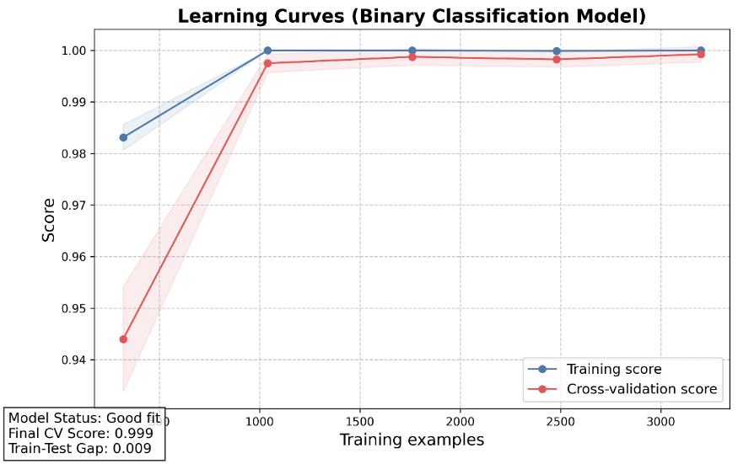

Figure 5.1. Learning Curves (Binary Classification Model)

The graph of the regression model shows that the coefficient of determination (R²) on the training and testing sets both increase steadily and approach 1.0, specifically the final cross-validation score is 0.992 and the train-test distance is only 0.013, reflecting the ability to predict the compatibility score very accurately (Figure 5.2).

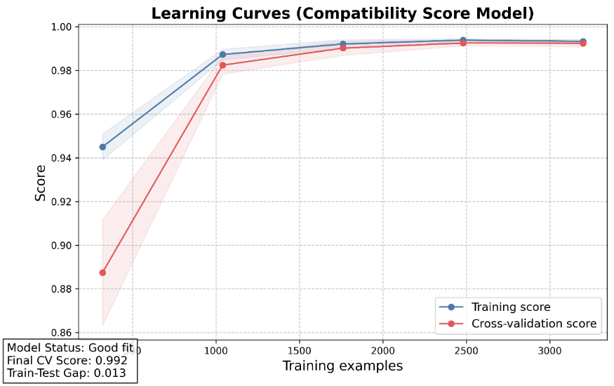

Figure 5.2. Learning Curves (Compatibility Score Model)

Meanwhile, the chart of the ranking model shows a large deviation between the training and testing sets, with a score difference of 0.225 and a CV score of –0.235 (Figure 5.3). The overfitting condition becomes evident because the model effectively learns known data, but it struggles to adapt to new data.

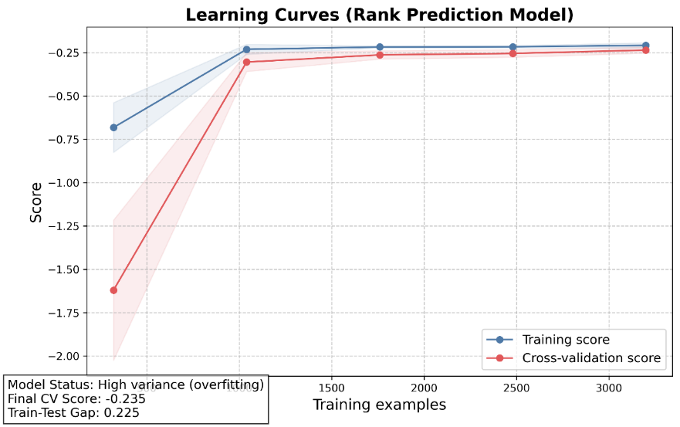

Figure 5.3. Learning Curves (Rank Prediction Model)

However, since the purpose of using the ranking model in this system is not to predict alone, but to combine it with a regression model to reorder the filtered list of dishes, such a slight degree of overfitting is still acceptable in the initial deployment phase. By implementing a regression score-based filter together with a binary classification model, we have decreased the chance of model overfitting. Overall, the first two models have good and stable performance, while the ranking model needs further improvement to avoid bias in real-world deployment.

## 5.3. Performance of Individual Models

I developed four different machine learning models across the system to execute food label classification, relevance score prediction (regression), ranking and binary classification. The classification model was only used to encode the labels, to help train the other models, and was not used for direct evaluation. The regression model delivered outstanding performance as it produced training MSE of 0.0242 and test MSE of 0.0276, with respective high R² values of 0.9935 and 0.9930. The high-impact features in the model include “interaction_angry_Magnesium” and “interaction_disgust_Dietary Fiber” (Figure 5.4).

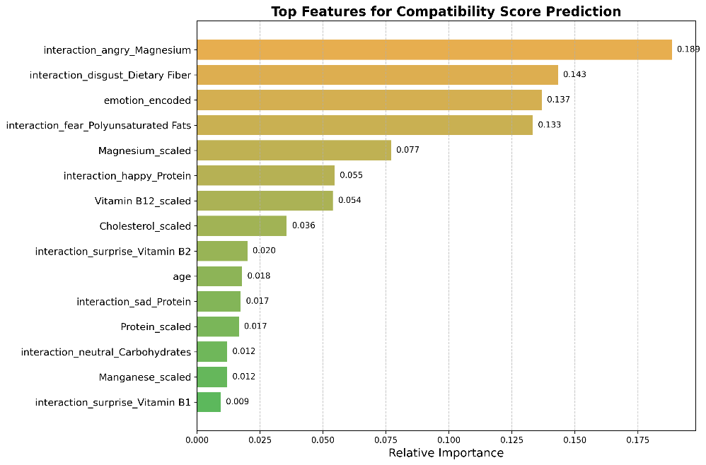

Figure 5.4. Top Features for Compatibility Score Prediction

For further explanation, I used the SHAP plot (Figure 5.5). This chart ranks the features by their average influence on the model output and encodes the feature value with color (red = high, blue = low). The horizontal axis shows the change in the predicted output when changing the feature value. The fact that more red points appear to the right indicates that when the value of that feature is high, the probability of recommending the dish will increase significantly.

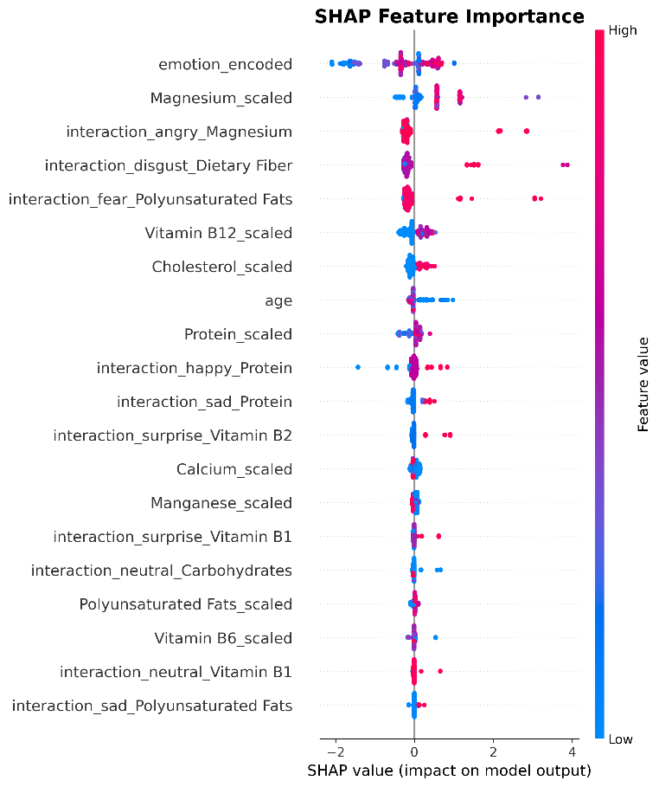

Figure 5.5. SHAP Feature Importance (for regression model)

The validation of the ranking model shows R² = 0.9748 for training while achieving R² = 0.9699 for testing (Figure 5.6).

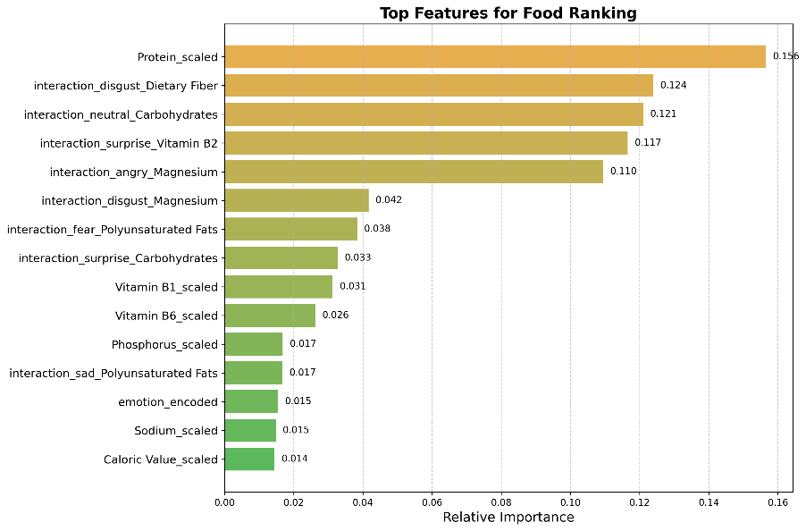

Figure 5.6. Top features for Food Ranking

The model properly ranks the dishes based on its MSE values of 0.2093 for training and 0.2436 for testing.

The binary classification achieved full accuracy on training data which translated to 99.9% accuracy on testing data. Each influence value distribution for dataset features is displayed using a “swarm plot” structure in the SHAP plot, where the SHAP interaction values have minimal effect for most features; however, some features demonstrate slight interaction effects that call for further exploration (Figure 5.7).

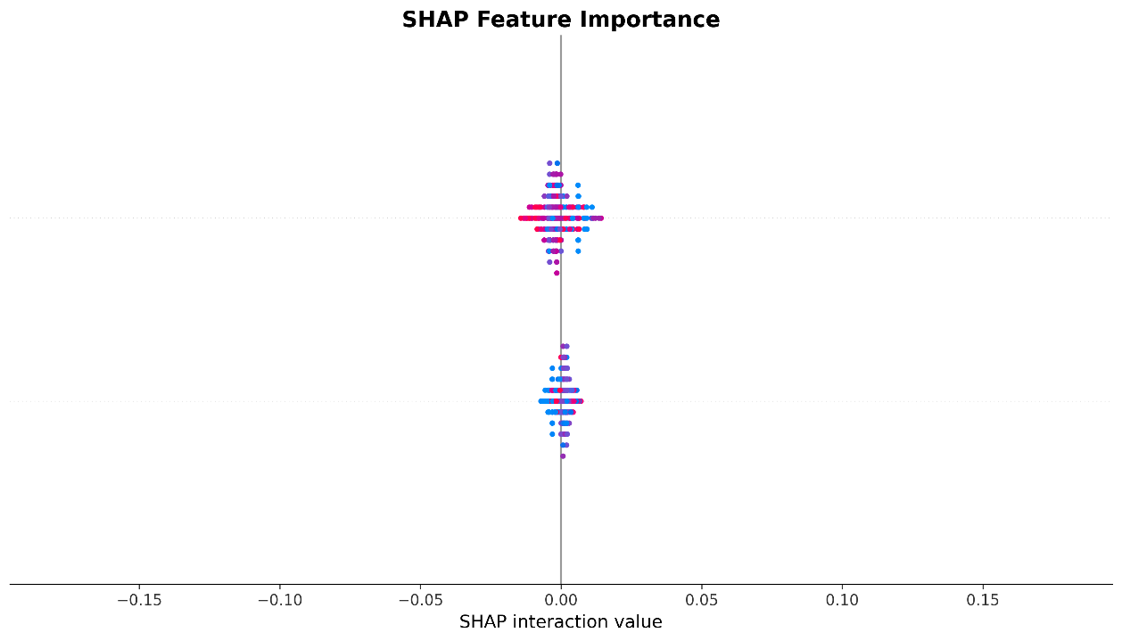

Figure 5.7. SHAP Feature Importance (for binary model)

The emotions and their interactions with Magnesium, Dietary Fiber and Protein produced the most significant impact on the results (Figure 5.8).

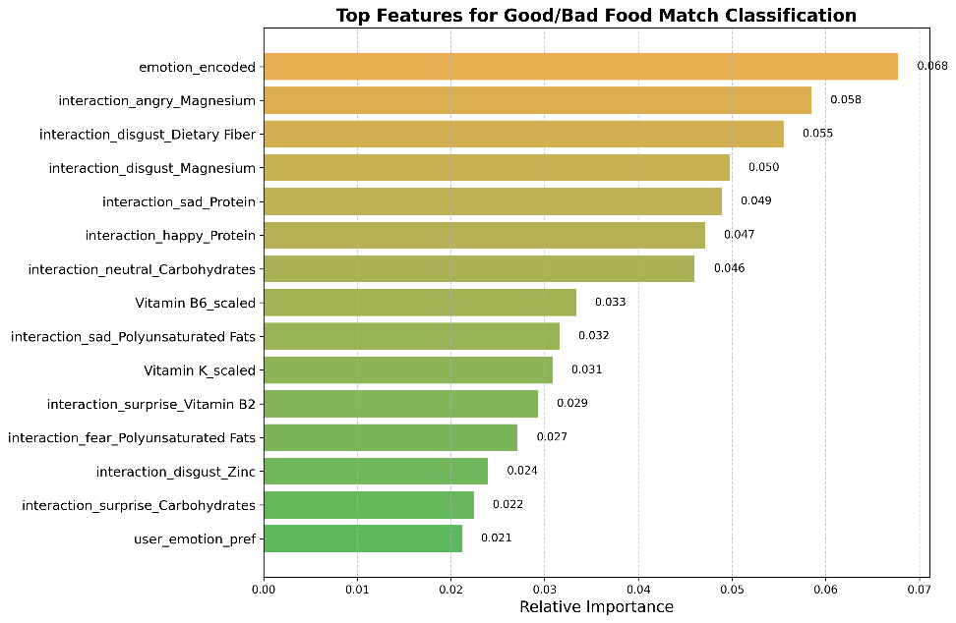

Figure 5.8. Top features for Good/Bad Food Match Classification

Multiple features create dynamic effects on relevance since their values ​​show double peaks centered at zero in the data. An important example of this occurs with “interaction_sad_Protein”. Finally, the performance of the binary classification model is validated through the confusion matrix (Figure 5.9), in which Precision reaches 0.998, Recall = 1.000, F1 = 0.999, showing that the system almost does not make any significant errors in determining whether the food is “good” or “bad” for the user’s emotions.

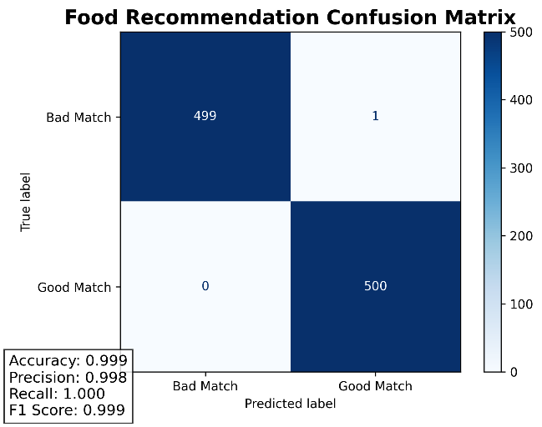

Figure 5.9. Confusion matrix of Good/Bad Food Match Classification

## 5.4. Nutrient Correlation with Model Prediction

I studied how emotional states link to food nutrients by examining the correlation between nutritional values in the food and each emotional outcome predicted by the model. The result (Figure 5.10) presents seven different emotions: “sad”, “happy”, “angry”, “disgust”, “neutral”, “surprised”, and “fearful”.

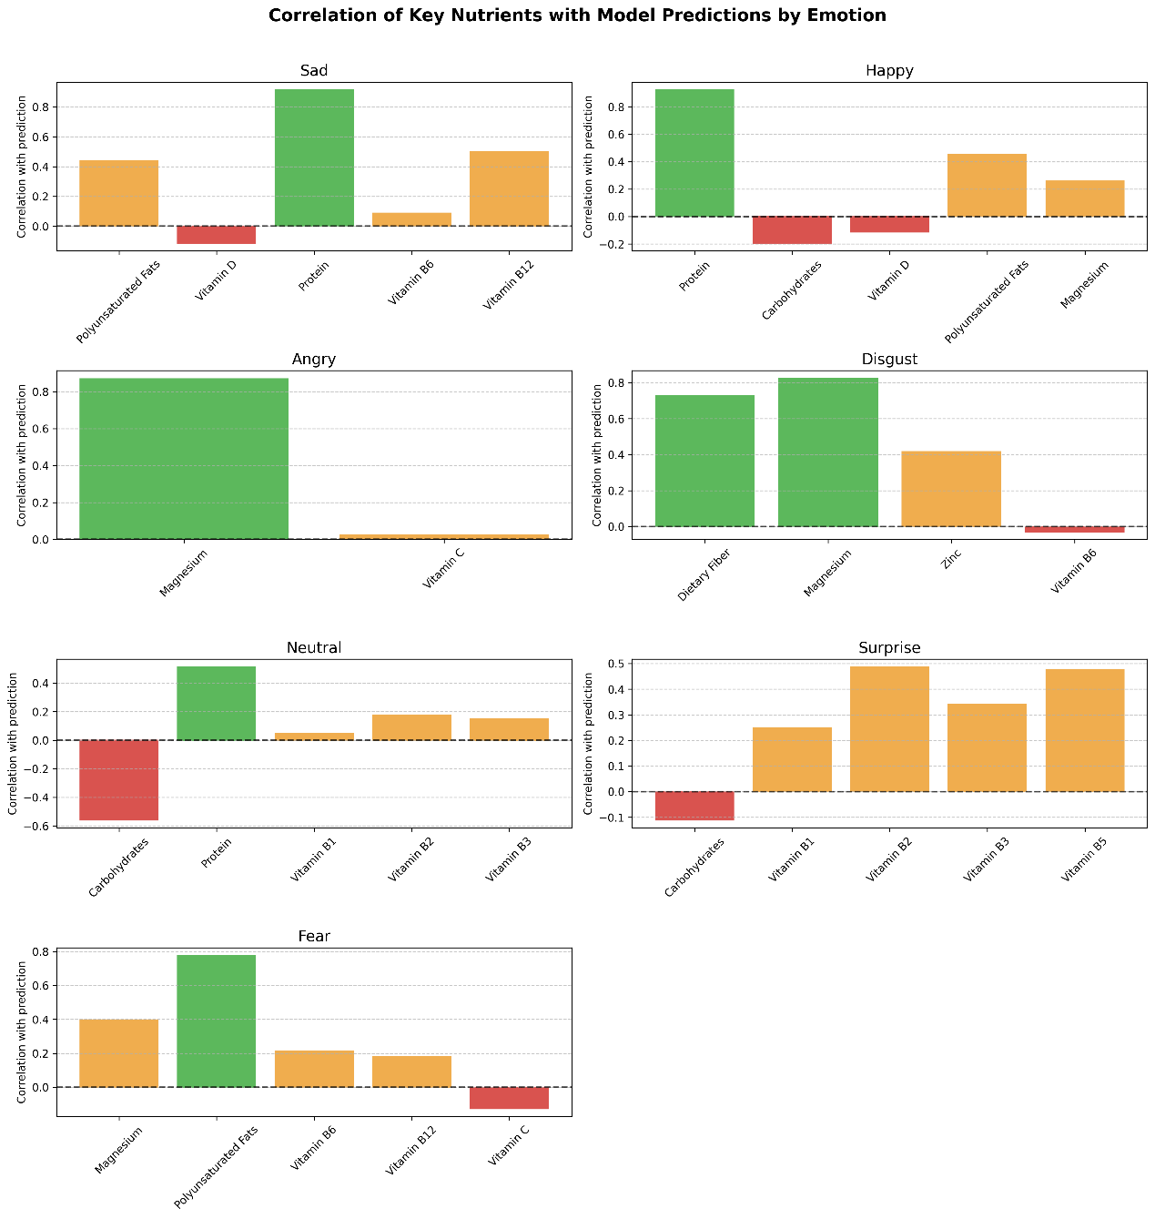

Figure 5.10. Correlation of Key Nutrients with Model Predictions by Emotion

The analysis shows that some nutrients are particularly strongly correlated with specific emotions. For example, Happy and Sad emotions are most closely linked to Protein, whereas Magnesium shows its strongest connection with Angry and Disgust emotions. The nutritional value of Polyunsaturated Fats links to negative emotions, along with Fear, while Carbohydrates show a negative connection to Neutral and Surprise emotional states.

In addition, a heatmap (Figure 5.11) presents the aggregate compatibility metrics between each food category and emotional condition (Fruits, Meat, Grains, etc. & emotions). The analysis reveals that meat products and grains display superior negative emotion compatibility than fruits and beverages.

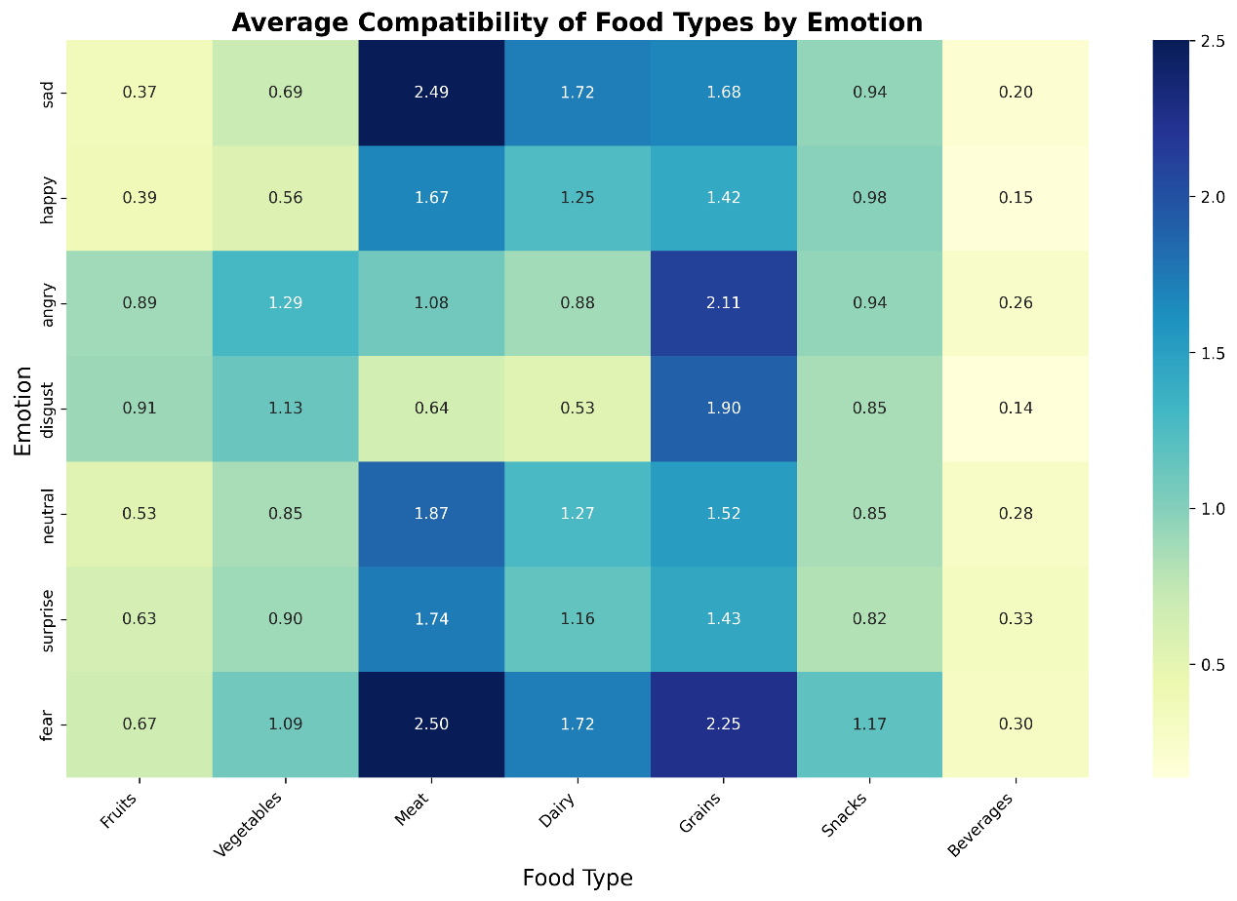

Figure 5.11. Average Compatibility of Food Types by Emotion

Research results demonstrate that the model excels not only in pattern recognition but also represents nutritional science mechanisms regarding emotions to provide dependable personal recommendation services.

## 5.5. Comparative Evaluation with Direct Scoring

To test the degree of difference between the machine learning model and the manual scoring method (direct scoring), I compared the output score distributions from the two systems. The results are shown in two graphs: the score distribution and the score difference distribution (Figure 5.12).

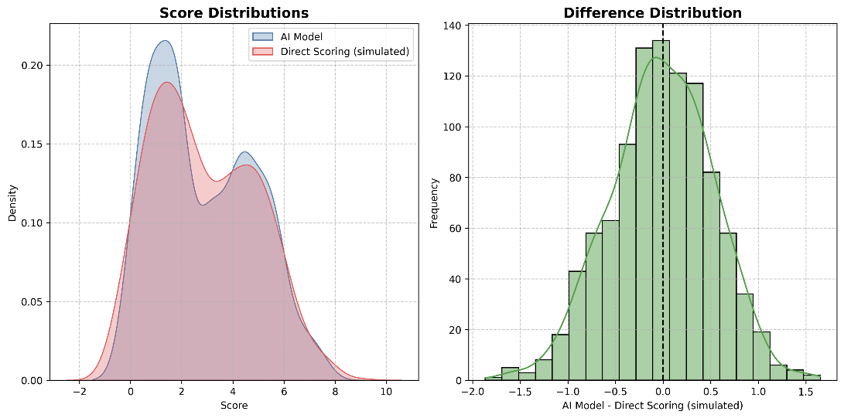

Figure 5.12. Statistical Comparison

The conventional scoring system shares similar score distribution patterns with AI-driven computer programs though the AI ​​protocol shows greater cluster differentiation in its generated scores. Meanwhile, the distribution of the direct scoring method appears smooth because its calculation method depends linearly on distance to standard values.

The right graph shows that the distribution between the two methods almost follows a normal distribution, centered around the value 0. This shows that despite the small differences, the results of the AI ​​model are relatively consistent with the traditional method.

Thus, the evaluation logic seems to be modeled via machine learning, along with the capability to discover advanced patterns that traditional evaluation logic finds challenging to represent.

## 5.6. Comprehensive Evaluation

My evaluation involved testing 294 input conditions, which covered all possible combinations between emotional states, food types, mealtimes and age groups. The results were compared between two versions of the data: full and reduced (Figure 5.13).

Figure 5.13. Overall Comprehensive Evaluation Results

On the full data set, the model performed at 87.07% in Top-1 accuracy while delivering 74.72% in Top-3 overlap during tests that consumed 4.93 seconds of computer processing time each request. Meanwhile, the reduced data set gave superior results, with Top-1 Accuracy of up to 94.90% and Top-3 Overlap of 86.05%, while significantly reducing the processing time to 0.85 seconds.

This result shows that reducing the input features not only helps optimize the response speed but can also improve the accuracy of the proposed system. Real-time emotional food recommendation systems along with smart restaurant menus require this level of stability in their operation.

## 5.7. Personalization Feedback Simulation

I designed five user interaction rounds through which participants could show appreciation or disapproval towards the system recommendations. Based on this feedback, the system automatically adjusted the personal preference score for each dish in the following rounds.

Each gathered user response during feedback rounds resulted in the recommendations showing higher coherence with individual preferences. Specifically, the number of repeated dishes decreased, and the "liked" dish often appeared in the first position in the following rounds.

The simulation demonstrated that the personalization method dependent on observer behaviors allows systems to increase their intelligence through learning without model retraining requirements.

## 5.8. Discussion and Implications

Research indicates that artificial intelligence, united with behavioral and nutritional elements, creates substantial prospects to provide highly personalized food recommendations. Building a model based on the relationship between emotions and nutrition not only increases the scientific quality of the recommendation but also opens new approaches for healthcare and food service applications.

The model presents outstanding performance metrics through all assessment methods (regression, ranking, binary classification) while working on the condensed dataset, which ensures both dependable results and rapid output capabilities. Intelligent feature selection methods generate better results compared to simply increasing the number of variables since they improve both system execution and implementation feasibility. In addition, the system easily adjusts its responses to individual user preferences because its simple feedback mechanism operates without requiring assistance from technical model retraining.

However, multiple better opportunities exist for this system to advance its capabilities. The data used in the study is mostly simulated data, which does not fully reflect real-life behavior. Furthermore, some models, such as ratings, still have a slight overfitting phenomenon, which needs to be further refined if applied on a large scale. In the future, the system must be connected to authentic user data from mobile devices and restaurant programs to verify its operational effectiveness in operational environments. At the same time, the model can also be expanded to support other goals such as stress prevention, sleep support, or daily energy regulation through emotional eating.

# Chapter Six – Conclusion and Future Work

## 6.1. Conclusion

In conclusion, the thesis produced a food suggestion application through using both machine learning models together with emotion recognition systems to analyze user mood. I developed a model that analyzed how nutrition affects emotional state so it could rate diet suitability for different emotions, then suggest appropriate foods for keeping positive moods. During the process, Random Forest served as the primary algorithm for determining food-emotion compatibility and I built an application interface using React Native to serve users through a Flask-based backend for model execution and data processing. Experimental evaluation results show that the system achieves high accuracy with fast response time, especially on the reduced dataset, when Top-1 Accuracy is up to 94.90%. In addition, users can expect their system to adapt automatically to their preferences because of built-in personalization, which uses their selection data. Thereby, the thesis has demonstrated the potential of applying artificial intelligence in the field of emotional personalized nutrition recommendations.

## 6.2. Future Work

Although the current system has been running effectively on simulated data, I understand there is still a lot of potential for expansion and improvement of the system. In the future, I will acquire real data through application users or establish partnerships with intelligent restaurant franchises to construct a broad dataset that properly captures behavior patterns in emotional food selection. The detection of complicated connections between emotions, eating behaviors and nutritional requirements would be enhanced through the proposed experiment of Gradient Boosting Machines, XGBoost and Neural Collaborative Filtering algorithms, along with others. The system requires additional functionality which includes monitoring heart rate along with sleep patterns and activity levels to make full-scale recommendations on physical and mental health. The system will serve as my personal health care companion after I develop features like stress-prevention diet advice and sleep support and daily energy regulation.

# APPENDIX

**Appendix A – Monthly Project Timeline**

|  |  |  |  |  |
| --- | --- | --- | --- | --- |
| **Month** | **Task Name** | **Start** | **End** | **Duration (days)** |
| **January** | **Stage 1: Research & Preparation** | 1/12/2025 | 1/20/2025 | 9 |
| Gather documents on AI/ML and Classification algorithms | 1/12/2025 | 1/13/2025 | 2 |
| Data Collection | 1/14/2025 | 1/17/2025 | 4 |
| Design the survey | 1/18/2025 | 1/19/2025 | 2 |
| Write and submit project proposal | 1/19/2025 | 1/20/2025 | 2 |
| **Stage 2: Data Processing and AI Model Development** | 1/21/2025 | 2/22/2025 | 34 |
| Clean and preprocess data | 1/21/2025 | 1/24/2025 | 4 |
| Define a MoSCow method | 1/21/2025 | 1/24/2025 | 4 |
| Select model algorithms | 1/25/2025 | 1/27/2025 | 3 |
| Train AI model (first version) | 1/28/2025 | 2/4/2025 | 8 |
| **February** | Improve model and evaluate performance (final version) | 2/5/2025 | 2/19/2025 | 15 |
| Write Research report | 2/20/2025 | 2/22/2025 | 3 |
| **Stage 3: Application development** | 2/23/2025 | 3/25/2025 | 31 |
| Deploy model into Flask | 2/23/2025 | 2/26/2025 | 4 |
| Create first sketches and Figma Design | 2/27/2025 | 2/28/2025 | 2 |
| **March** | Develop basic interface on React Native | 3/1/2025 | 3/7/2025 | 7 |
| Connect Flask backend with React Native via API | 3/8/2025 | 3/13/2025 | 6 |
| Integrate AI model into React Native application | 3/14/2025 | 3/20/2025 | 7 |
| Test Application | 3/21/2025 | 3/25/2025 | 5 |
| **Stage 4: Finalize the project** | 3/26/2025 | 5/2/2025 | 38 |
| Draft final proposal | 3/26/2025 | 4/13/2025 | 19 |
| **April** | Write Experiment | 4/14/2025 | 4/19/2025 | 20 |
| User Requirement | 4/20/2025 | 4/22/2025 | 3 |
| Submit Proposal Report | 4/23/2025 | 4/23/2025 | 1 |
| Complete final report | 4/24/2025 | 4/26/2025 | 3 |
| Conduct final testing to ensure no errors remain | 4/27/2025 | 4/29/2025 | 3 |
| Prepare demo and presentation | 4/30/2025 | 5/1/2025 | 2 |
| **May** | Submit Research (Progress) + Final Report + Final Product | 5/2/2025 | 5/2/2025 | 1 |

Appendix A. Monthly Project Timeline

**Appendix B – Gantt Chart of Project Execution**

Appendix B. Gantt Chart of Project Execution

**Appendix C – Work Breakdown Structure (WBS)**

Appendix C. Work Breakdown Structure (WBS)

**Appendix D - List of priority nutrients in different moods table**

|  |  |  |  |  |
| --- | --- | --- | --- | --- |
| Mood | Priority | Nutrient | Effectiveness | References |
| Sad | 1 | Polyunsaturated Fats | Reduces inflammation and improves depressive symptoms, especially EPA is shown effective in RCTs. | (Muscaritoli, 2021) |
| 2 | Vitamin D | Enhances serotonin synthesis through gene activation (TPH2), supports emotional recovery. | (Owoyemi *et al.*, 2024) |
| 3 | Protein | Precursor to serotonin; when consumed with carbohydrates, increases serotonin availability in brain. | (Lakhan and Vieira, 2008) |
| 4 | Vitamin B6 | Cofactors in synthesis of serotonin and dopamine; supplementation reduces depressive symptoms. | (Young *et al.*, 2019) |
| 5 | Vitamin B12 |
| 6 | Magnesium | Calms the nervous system, regulates GABA, and improves mood and sleep in depression. | (Muscaritoli, 2021) |
| 7 | Zinc | Modulates NMDA receptors, reduces neuroinflammation, supports mood regulation and cognition. | (Horovitz, 2025) |
| Fear | 1 | Magnesium | Reduces stress and anxiety by regulating HPA axis and enhancing GABAergic activity. | (Muscaritoli, 2021) |
| 2 | Polyunsaturated Fats | Decreases inflammation and cortisol; improves emotional resilience under chronic stress. | (Muscaritoli, 2021) |
| 3 | Vitamin B6 | Antioxidant; reduces oxidative stress and modulates cortisol and neurotransmitter synthesis. | (Young *et al.*, 2019) |
| 4 | Vitamin B12 |
| 5 | Vitamin C | Improved symptoms in alcoholic men with latent scurvy | (Horovitz, 2025) |
| Neutral | 1 | Carbohydrates | Provides steady glucose to support brain energy and stable mood. | (Horovitz, 2025) |
| 2 | Protein | Supplies amino acids needed for neurotransmitter synthesis. | (Lakhan and Vieira, 2008) |
| 3 | Vitamin B1 | Supports energy metabolism, brain cell function, and cognitive performance. | (Tardy *et al.*, 2020) |
| 4 | Vitamin B2 |
| 5 | Vitamin B3 |
| 6 | Vitamin B5 |
| 7 | Vitamin B6 |
| 9 | Vitamin B12 |
| 10 | Magnesium | Oxygen transport, energy production  Supports neurological function and energy metabolism | (Tardy *et al.*, 2020) |
| 11 | Zinc |
| 12 | Iron | Supports oxygen delivery and enhances attention, memory, and cognitive function. | (Tardy *et al.*, 2020) |
| Happy | 1 | Protein | Provides tryptophan for as a precursor to serotonin; supports mood elevation when consumed with carbohydrates. | (Lakhan and Vieira, 2008) |
| 2 | Carbohydrates | Boosts insulin, promotes tryptophan uptake in brain, thereby increasing serotonin synthesis. | (Horovitz, 2025) |
| 3 | Vitamin D | Modulates serotonin production; associated with positive mood and emotional well-being. | (Owoyemi *et al.*, 2024) |
| 4 | Polyunsaturated Fats | Regulates emotion, reduces cortisol, enhances mood stability and cognitive function. | (Muscaritoli, 2021) |
| 5 | Magnesium | Regulates neurotransmitters; promotes calm, positive mood and reduces mild emotional imbalance. | (Muscaritoli, 2021) |
| Surprise | 1 | Carbohydrates | Provides immediate energy; enhances alertness and attention in response to novelty or stimulus. | (Horovitz, 2025) |
| 2 | Vitamin B1 | Supports energy metabolism and neurotransmitter synthesis under acute cognitive demand. | (Tardy *et al.*, 2020) |
| 3 | Vitamin B2 |
| 4 | Vitamin B3 |
| 5 | Vitamin B5 |
| 6 | Vitamin B6 |
| 7 | Vitamin B12 |
| 8 | Protein | Provides tyrosine as a precursor for dopamine and norepinephrine, enhancing cognitive speed and motivation. | (Horovitz, 2025) |
| 9 | Vitamin C | Modulate neuroimmune function; contribute to mood regulation and acute cognitive response. | (Tardy *et al.*, 2020) |
| 10 | Vitamin D |
| Disgust | 1 | Dietary Fiber | Improves gut motility, binds toxins, restores digestive comfort after visceral or food-related disgust. | (Yılmaz and Gökmen, 2020) |
| 2 | Magnesium | Calms visceral tension; may reduce nausea, gut reactivity and somatic response to aversive stimuli. | (Muscaritoli, 2021) |
| 3 | Zinc | Supports mucosal healing, immune modulation, and gut-brain axis recovery after nausea/discomfort. | (Horovitz, 2025) |
| 4 | Vitamin B6 | Supports GABA synthesis; may alleviate visceral discomfort linked to disgust. | (Yılmaz and Gökmen, 2020) |
| Angry | 1 | Magnesium | Calms the nervous system via GABA regulation; reduces excitability and stress-induced aggression. | (Muscaritoli, 2021) |
| 2 | Vitamin C | Reduces oxidative stress and cortisol; supports adrenal balance under emotional reactivity. | (Horovitz, 2025) |

Appendix D. List of priority nutrients in different moods table

**Appendix E – Recommended Daily Intake For each Nutrient table**

|  |  |  |  |  |
| --- | --- | --- | --- | --- |
| Nutrient | Children (< 16 years) | Adults (>= 16 years) | Unit |  |
| Caloric Value | 1800 | 3300 | kcal/day | (Tee *et al.*, 2023) |
| Fat | 70000 | 128333.33 | mg/day | (Godos *et al.*, 2020) |
| Polyunsaturated Fats | 3000 | 3000 | mg/day | (Godos *et al.*, 2020) |
| Carbohydrates | 292500 | 536250 | mg/day | (Tee *et al.*, 2023) |
| Sugars | 45000 | 82500 | mg/day | (Tee *et al.*, 2023) |
| Protein | 27000 | 71000 | mg/day | (Tee *et al.*, 2023) |
| Dietary Fiber | 13000 | 30000 | mg/day | (Tee *et al.*, 2023) |
| Sodium | 1500 | 2000 | mg/day | (Tee *et al.*, 2023) |
| Vitamin A | 900 | 3000 | mg/day | (Murphy and Barr, 2006; Tee *et al.*, 2023) |
| Vitamin B1 | 0.7 | 1.4 | mg/day | (Tee *et al.*, 2023) |
| Vitamin B11 | 0.4 | 1 | mg/day | (Murphy and Barr, 2006; Tee *et al.*, 2023; Turck, Bohn, Castenmiller, de Henauw, Hirsch‐Ernst, Knutsen, Maciuk, Mangelsdorf, McArdle, Pentieva, Siani, Thies, Tsabouri, Vinceti, Crous‐Bou, *et al.*, 2023) |
| Vitamin B12 | 0.0015 | 0.003 | mg/day | (Tee *et al.*, 2023) |
| Vitamin B2 | 0.7 | 1.7 | mg/day | (Tee *et al.*, 2023) |
| Vitamin B3 | 12 | 16 | mg/day | (Murphy and Barr, 2006; Tee *et al.*, 2023) |
| Vitamin B5 | 4 | 5 | mg/day | (Tee *et al.*, 2023) |
| Vitamin B6 | 0.9 | 1.7 | mg/day | (Tee *et al.*, 2023) |
| Vitamin C | 50 | 100 | mg/day | (Murphy and Barr, 2006; Tee *et al.*, 2023) |
| Vitamin D | 0.015 | 0.015 | mg/day | (‘Scientific Opinion on the Tolerable Upper Intake Level of vitamin D’, 2012; Tee *et al.*, 2023) |
| Vitamin E | 7 | 15 | mg/day | (Murphy and Barr, 2006; Tee *et al.*, 2023) |
| Vitamin K | 0.06 | 0.12 | mg/day | (Tee *et al.*, 2023) |
| Calcium | 1000 | 2500 | mg/day | (‘Scientific Opinion on the Tolerable Upper Intake Level of calcium’, 2012; Tee *et al.*, 2023) |
| Copper | 0.7 | 0.9 | mg/day | (Tee *et al.*, 2023) |
| Iron | 10 | 18 | mg/day | (Tee *et al.*, 2023; Turck *et al.*, 2024) |
| Magnesium | 200 | 420 | mg/day | (Murphy and Barr, 2006; Tee *et al.*, 2023) |
| Manganese | 1.5 | 2.3 | mg/day | (Tee *et al.*, 2023; Turck, Bohn, Castenmiller, de Henauw, Hirsch‐Ernst, Knutsen, Maciuk, Mangelsdorf, McArdle, Pentieva, Siani, Thies, Tsabouri, Vinceti, Bornhorst, *et al.*, 2023) |
| Phosphorus | 800 | 1250 | mg/day | (Tee *et al.*, 2023) |
| Potassium | 2600 | 4700 | mg/day | (Tee *et al.*, 2023) |
| Zinc | 12 | 40 | mg/day | (Murphy and Barr, 2006; Tee *et al.*, 2023) |

Appendix E. Recommended Daily Intake For each Nutrient table

**Appendix F – GitHub Source Code**

Project source code is available at: <https://github.com/NamBobby/food-recommendation-app>

Appendix F. Github Source Code

# REFERENCES

Bolger, N. *et al.* (1989) ‘Effects of daily stress on negative mood.’, *Journal of Personality and Social Psychology*, 57(5), pp. 808–818. Available at: <https://doi.org/10.1037/0022-3514.57.5.808>. [Accessed January 2025]

Gao, S. *et al.* (2022) ‘Associations between self-disgust, depression, and anxiety: A three-level meta-analytic review’, *Acta Psychologica*, 228, p. 103658. Available at: <https://doi.org/10.1016/j.actpsy.2022.103658>. [Accessed February 2025]

Gardner, M.P. *et al.* (2014) ‘Better moods for better eating?: How mood influences food choice’, *Journal of Consumer Psychology*, 24(3), pp. 320–335. Available at: <https://doi.org/10.1016/j.jcps.2014.01.002>. [Accessed January 2025]

Ghaemi Kerahrodi, J. and Michal, M. (2020) ‘The fear-defense system, emotions, and oxidative stress’, *Redox Biology*, 37, p. 101588. Available at: <https://doi.org/10.1016/j.redox.2020.101588>. [Accessed February 2025]

Godos, J. *et al.* (2020) ‘Diet and Mental Health: Review of the Recent Updates on Molecular Mechanisms’, *Antioxidants*, 9(4), p. 346. Available at: <https://doi.org/10.3390/antiox9040346>. [Accessed February 2025]

Gupta, M. *et al.* (2021) ‘Mood Based Food Recommendation System’, in *2021 Asian Conference on Innovation in Technology (ASIANCON)*. IEEE, pp. 1–6. Available at: <https://doi.org/10.1109/ASIANCON51346.2021.9545065>. [Accessed February 2025]

Horovitz, O. (2025) ‘Nutritional Psychology: Review the Interplay Between Nutrition and Mental Health’, *Nutrition Reviews*, 83(3), pp. 562–576. Available at: <https://doi.org/10.1093/nutrit/nuae158>. [Accessed February 2025]

Jain, D.K., Shamsolmoali, P. and Sehdev, P. (2019) ‘Extended deep neural network for facial emotion recognition’, *Pattern Recognition Letters*, 120, pp. 69–74. Available at: <https://doi.org/10.1016/j.patrec.2019.01.008>. [Accessed January 2025]

Jang, E.-H. *et al.* (2015) ‘Analysis of physiological signals for recognition of boredom, pain, and surprise emotions’, *Journal of Physiological Anthropology*, 34(1), p. 25. Available at: <https://doi.org/10.1186/s40101-015-0063-5>. [Accessed February 2025]

Kitayama, S. and Park, J. (2017) ‘Emotion and biological health: the socio-cultural moderation’, *Current Opinion in Psychology*, 17, pp. 99–105. Available at: <https://doi.org/10.1016/j.copsyc.2017.06.016>. [Accessed February 2025]

Lakhan, S.E. and Vieira, K.F. (2008) ‘Nutritional therapies for mental disorders’, *Nutrition Journal*, 7(1), p. 2. Available at: <https://doi.org/10.1186/1475-2891-7-2>. [Accessed January 2025]

Martinez-Gorospe, A. *et al.* (2021) ‘Food recommender system based on weighted ingredients, body mass index and allergies; using the Random Forest algorithm’, in *2021 Mexican International Conference on Computer Science (ENC)*. IEEE, pp. 1–7. Available at: <https://doi.org/10.1109/ENC53357.2021.9534806>. [Accessed January 2025]

Murphy, S.P. and Barr, S.I. (2006) ‘Recommended Dietary Allowances should be used to set Daily Values for nutrition labeling’, *The American Journal of Clinical Nutrition*, 83(5), pp. 1223S-1227S. Available at: <https://doi.org/10.1093/ajcn/83.5.1223S>. [Accessed February 2025]

Muscaritoli, M. (2021) ‘The Impact of Nutrients on Mental Health and Well-Being: Insights From the Literature’, *Frontiers in Nutrition*, 8. Available at: <https://doi.org/10.3389/fnut.2021.656290>. [Accessed February 2025]

Owoyemi, E.P. *et al.* (2024) ‘Nutritional Genomics: The Use of Personalized Diets for Managing Depression’, *Journal of Complementary and Alternative Medical Research*, 25(11), pp. 23–37. Available at: <https://doi.org/10.9734/jocamr/2024/v25i11581>. [Accessed February 2025]

Padhiar, I. *et al.* (2021) ‘Semantic Modeling for Food Recommendation Explanations’, in *2021 IEEE 37th International Conference on Data Engineering Workshops (ICDEW)*. IEEE, pp. 13–19. Available at: <https://doi.org/10.1109/ICDEW53142.2021.00010>. [Accessed March 2025]

Schlechter, P. *et al.* (2023) ‘The Short Mood and Feelings Questionnaire from adolescence to emerging adulthood: Measurement invariance across time and sex.’, *Psychological Assessment*, 35(5), pp. 405–418. Available at: <https://doi.org/10.1037/pas0001222>. [Accessed February 2025]

‘Scientific Opinion on the Tolerable Upper Intake Level of calcium’ (2012) *EFSA Journal*, 10(7). Available at: <https://doi.org/10.2903/j.efsa.2012.2814>. [Accessed February 2025]

‘Scientific Opinion on the Tolerable Upper Intake Level of vitamin D’ (2012) *EFSA Journal*, 10(7). Available at: <https://doi.org/10.2903/j.efsa.2012.2813>. [Accessed February 2025]

Smith, T.W. *et al.* (2004) ‘Hostility, Anger, Aggressiveness, and Coronary Heart Disease: An Interpersonal Perspective on Personality, Emotion, and Health’, *Journal of Personality*, 72(6), pp. 1217–1270. Available at: <https://doi.org/10.1111/j.1467-6494.2004.00296.x>. [Accessed February 2025]

Steptoe, A. (2019) ‘Happiness and Health’, *Annual Review of Public Health*, 40(1), pp. 339–359. Available at: <https://doi.org/10.1146/annurev-publhealth-040218-044150>. [Accessed February 2025]

Tardy, A.-L. *et al.* (2020) ‘Vitamins and Minerals for Energy, Fatigue and Cognition: A Narrative Review of the Biochemical and Clinical Evidence’, *Nutrients*, 12(1), p. 228. Available at: <https://doi.org/10.3390/nu12010228>. [Accessed February 2025]

Tee, E.S. *et al.* (2023) ‘Review of recommended energy and nutrient intake values in Southeast Asian countries’, *Malaysian Journal of Nutrition*, 29(2). Available at: <https://doi.org/10.31246/mjn-2023-29-2-rni-rda-sea-review>. [Accessed February 2025]

Turck, D., Bohn, T., Castenmiller, J., de Henauw, S., Hirsch‐Ernst, K., Knutsen, H.K., Maciuk, A., Mangelsdorf, I., McArdle, H.J., Pentieva, K., Siani, A., Thies, F., Tsabouri, S., Vinceti, M., Crous‐Bou, M., *et al.* (2023) ‘Scientific opinion on the tolerable upper intake level for folate’, *EFSA Journal*, 21(11). Available at: <https://doi.org/10.2903/j.efsa.2023.8353>. [Accessed February 2025]

Turck, D., Bohn, T., Castenmiller, J., de Henauw, S., Hirsch‐Ernst, K., Knutsen, H.K., Maciuk, A., Mangelsdorf, I., McArdle, H.J., Pentieva, K., Siani, A., Thies, F., Tsabouri, S., Vinceti, M., Bornhorst, J., *et al.* (2023) ‘Scientific opinion on the tolerable upper intake level for manganese’, *EFSA Journal*, 21(12). Available at: <https://doi.org/10.2903/j.efsa.2023.8413>. [Accessed February 2025]

Turck, D. *et al.* (2024) ‘Scientific opinion on the tolerable upper intake level for iron’, *EFSA Journal*, 22(6). Available at: <https://doi.org/10.2903/j.efsa.2024.8819>. [Accessed February 2025]

Vaishnavi, S. *et al.* (2024) ‘Nutrition Recommendation System for Sports Persons using Random Forest Algorithm’, in *2024 International Conference on Smart Systems for Electrical, Electronics, Communication and Computer Engineering (ICSSEECC)*. IEEE, pp. 164–169. Available at: <https://doi.org/10.1109/ICSSEECC61126.2024.10649420>. [Accessed January 2025]

Vegesna, Dr.V. (2024) ‘AI-Driven Personalized Nutrition: A system for Tailored Dietary Recommendations’, *International Research Journal of Computer Science*, 11(07), pp. 545–550. Available at: <https://doi.org/10.26562/irjcs.2024.v1107.02>. [Accessed January 2025]

Yılmaz, C. and Gökmen, V. (2020) ‘Neuroactive compounds in foods: Occurrence, mechanism and potential health effects’, *Food Research International*, 128, p. 108744. Available at: <https://doi.org/10.1016/j.foodres.2019.108744>. [Accessed February 2025]

Young, L.M. *et al.* (2019) ‘A Systematic Review and Meta-Analysis of B Vitamin Supplementation on Depressive Symptoms, Anxiety, and Stress: Effects on Healthy and “At-Risk” Individuals’, *Nutrients*, 11(9), p. 2232. Available at: <https://doi.org/10.3390/nu11092232>. [Accessed February 2025]

Chen, X. and Ishwaran, H. (2012) ‘Random forests for genomic data analysis’, *Genomics*, 99(6), pp. 323–329. Available at: <https://doi.org/10.1016/j.ygeno.2012.04.003>. [Accessed March 2025]

Gorgoglione, M., Panniello, U. and Tuzhilin, A. (2019) ‘Recommendation strategies in personalization applications’, *Information & Management*, 56(6), p. 103143. Available at: <https://doi.org/10.1016/j.im.2019.01.005>. [Accessed March 2025]

Janiesch, C., Zschech, P. and Heinrich, K. (2021) ‘Machine learning and deep learning’, *Electronic Markets*, 31(3), pp. 685–695. Available at: <https://doi.org/10.1007/s12525-021-00475-2>. [Accessed March 2025]

Jubeile Mark Baladjay *et al.* (2023) ‘Performance evaluation of random forest algorithm for automating classification of mathematics question items’, *World Journal of Advanced Research and Reviews*, 18(2), pp. 034–043. Available at: <https://doi.org/10.30574/wjarr.2023.18.2.0762>. [Accessed February 2025]

LaValley, M.P. (2008) ‘Logistic Regression’, *Circulation*, 117(18), pp. 2395–2399. Available at: <https://doi.org/10.1161/CIRCULATIONAHA.106.682658>. [Accessed March 2025]

Milano, S., Taddeo, M. and Floridi, L. (2020) ‘Recommender systems and their ethical challenges’, *AI & SOCIETY*, 35(4), pp. 957–967. Available at: <https://doi.org/10.1007/s00146-020-00950-y>. [Accessed March 2025]

Mouhiha, M., Oualhaj, O.A. and Mabrouk, A. (2024) ‘Combining Collaborative Filtering and Content Based Filtering for Recommendation Systems’, in *2024 11th International Conference on Wireless Networks and Mobile Communications (WINCOM)*. IEEE, pp. 1–6. Available at: <https://doi.org/10.1109/WINCOM62286.2024.10658169>. [Accessed March 2025]

Parthasarathy, G. and Sathiya Devi, S. (2023) ‘Hybrid Recommendation System Based on Collaborative and Content-Based Filtering’, *Cybernetics and Systems*, 54(4), pp. 432–453. Available at: <https://doi.org/10.1080/01969722.2022.2062544>. . [Accessed March 2025]

Bungay, J.D.D., Matias, S.M.M., Santos, A.A., Arceno, P.C., Dalipe, C.F. and Lomotan, J.B., 2024. ‘DIAFOODS: A content-based food recommendation system for diabetic patients’. In: 2024 IEEE 9th International Conference on Computational Intelligence and Applications (ICCIA). IEEE. Available at: <https://doi.org/10.1109/ICCIA62557.2024.10719360>. [Accessed April 2025]

1. <https://huggingface.co/dima806/facial_emotions_image_detection>
2. <https://huggingface.co/google/vit-base-patch16-224-in21k>
3. <https://www.kaggle.com/datasets/utsavdey1410/food-nutrition-dataset>
4. <https://www.kaggle.com/datasets/beridzeg45/food-nutritional-facts?resource=download>
5. <https://www.kaggle.com/datasets/adilshamim8/daily-food-and-nutrition-dataset>